A project report on

**NewsPortal.com**

Submitted in partial fulfillment of the requirement for the award of the degree

MASTER OF COMPUTER APPLICATIONS

OF

Gujarat Technological University

(GTU)

**Vivek S. Mishra**

**135223693057**

**Dharmendra D. Meniya**

**135223693056**

**Shailesh K. Limbadiya**

**135223693078**

**Kuntal H. Vagadiya**

**135223693090**

Marwadi Education Foundation’s

Group of Institutions

(MEFGI)Rajkot, Gujarat.

2014 – 2015

**Marwadi Education Foundation Group of Institutions**

Morbi Road, At & Op: Gauridad, Rajkot-360 003.

Phone: - +91 281 2924154

Email: -info@marwadieducation.edu.in

**CERTIFICATE**

This is the certify that the report on

Website on News Portal

Shailesh K. Limbadiya, Dharmendra D. Meniya,

Vivek S. Mishra, Kuntal H. Vagadiya

Has been successfully completed the project of Marwadi Education Foundation Group of Institution. As on subject for Sem-V from our College for the year 2014-2015

He has successfully demonstrated it to staff. We are satisfied with their performance.

Date: - ___/____/20__

Project in charge Dean

(Prof. Pritesh Madlani) (Dr. R. Shreedharan) Marwadi Education Foundation Marwadi Education Foundation

Rajkot. Rajkot.

**DECLARATION**

We **Vivek S. Mishra, Dharmendra D. Meniya, Shailesh K. Limbadiya & Kuntal H. Vagadiya** hereby declare that this project work entitled **NewsPortal.com** is a record done by us.

We also declare that the matter embodied in this project is genuine work done by us and has not been submitted whether to this University or to any other University / Institute for the fulfillment of the requirement of any course of study.

Place:-

Date :-

**Vivek S. Mishra**

**Dharmendra D. Meniya**

**Shailesh K. Limbadiya**

**Kuntal H. Vagadiya**

**ACKNOWLEDGEMENT**

First of all we are glad to express our unsaid feelings to our almighty for helping me in the moment of the needs, for giving us a support all the time.

Co-ordination, constant help and guidance were got in the hands of **Prof. Pritesh Madlani** and other faculties, who were extremely helpful to us. He was always supportive & went out to do anything for us regarding the project. We are seriously obliged to him.

We are thankful to our project guide, who provided us a lot of valuable help, co-operation & guidance. We are highly obliged to him for providing us with continuous, invaluable & encouraging guiding throughout the project development.

We are also thankful to him who provided the information for our project to us.

Finally, thanks to the fishes who cheered up a luckier.

**Vivek S. Mishra**

**Dharmendra D. Meniya**

**Shailesh K. Limbadiya**

**Kuntal H. Vagadiya**

**CONTENTS**

|  |  |  |
| --- | --- | --- |
| **Chapters** | **Particulars** | **Sample Page No.** |
| **1** | **SYNOPSIS** | 6 |
| **2**  2.1 | **PREAMBLE**  Project Description | 7 |
| **3**  3.1  3.2 | **TECHNICAL DESCRIPTION**  Hardware Requirement  Software Requirement | 8  9 |
| **4**  4.1  4.2  4.2.1 | **SYSTEM DESIGN AND DEVELOPMENT**  Diagram Design  Database Design  Table Structure | 10  15  16 |
| **5**  5.1  5.2  5.3 | **SYSTEM TESTING**  Blackbox Testing  Whitebox Testing  Integrated Testing | 19 |
| **6**  6.1  6.2 | **SOURCE CODE**  Client Side  Admin Side | 20  36  57 |
| **7**  7.1  7.2 | **SCREEN SHOTS**  Admin Side  Client Side | 103  115 |
| **8** | **CONCLUSION** | 127 |
| **9** | **BIBLIOGRAPHY** | 128 |

**SYNOPSIS**

* The News Publishing portal provides an easy way to professionally publish an online news publication, corporate press releases, or manage other content without technical expertise. It is most often used as an online newspaper.
* Our News Publishing system provides flexible, easy-to-use content management focused on minimizing. It combines content creation, graphics, and publication controls.
* Design a website with wide range of custom modules like top stories section, breaking news section, advance search option, photo gallery, video uploading services etc.
* Authorized contributing writers can submit stories for editorial review and publication.
* Unlimited category tree system for adding news stories and special features. Unlimited number of dynamic news sections.
* Publishes a photo gallery with a story.

**PREAMBLE**

* Admin Side :-

1. In admin module administrator is the user who manage the whole system and all user of the web site.
2. Administrator can add, edit and delete the news of each category. He has database controller.
3. Administrator is the person who knows all things about the system.
4. Admin also maintain daily report for all news’s.
5. Administrator can also maintain user’s feedback and implement that kind of facility which is not available in previous website.

* Client Side :-

1. A user view all the new news in this web site.
2. User can create his/her account in this website and that can be useful to view news updates.
3. User can also search for which he /she wants.

**TECHNICAL REQUIREMENT**

* **Hardware Configuration:-**

Hardware is most important part if the project. The configuration of hardware is given below.

* **Server**
* **PC with Processor:** Minimum Pentium IV at 2 GHz
* **RAM:** Minimum 2 GB
* **Disk Space:** Minimum 5 GB (Excluding Data size)
* 104 Key board, monitor, mouse
* **Client**
* **PC with Processor:** Minimum Pentium IV at 1GHz
* **RAM:** Minimum 512 MB
* **Disk Space:** Minimum1GB
* 104 Key board, monitor, mouse
* **Software Configuration:-**

Software is most important part of the project. The configuration is given below.

* **Server**
* Microsoft Windows 7.
* Microsoft Windows 8.1
* Microsoft Office 2007
* xampp-win32-1.8.3
* **Client**

#### Window 7 or Windows 8.1

Mozilla Firefox

* Intenet Explorer
* Google Chroma
* Opera

(Should support JavaScript, Java Applets)

**SYSTEM DESIGN AND DEVELOPMENT**

Design phase deals with transforming the requirements, as described in the SRS document, into a form that is implemented using a programming language. The various designs of this system are shown as following:

* **Diagram:-**

1. **Data flow Diagram:-**

Data Flow diagram is a graphical representation of flow of data throughout the information system. Data flow diagrams illustrate how data is processed by a system in terms of inputs and outputs.

**NAME NOTATION DESCRIPTION**

External Entity External entities are objects outside the system, with which the system communicates.

Dataflow Dataflow are pipelines through which packets of information flow.

Process Transforms incoming data flow to output data flow.

Data Store Repositories of data in the system.

**Context Level Diagram:-**

Publish News Account Detail

Administrator

Users

Other Users

Account Detail Add Comments

New Account Feed Back

User Detail

General Detail

Content Detail

Edit Info.

View Search

Upload Info.

Search Info.

Edit Info. Display Info

Manage Info.

User Info. Account Info.

Save Date

­

Database

Level 1 DFD

1. **Entity Relationship Diagram:-**

Web Based News

News

Administrator

Unregistered User

Belongs To

Committee

No

Yes

1. **Use Case Diagram :-**

Registered User

Unregistered User

Admin

**DATABASE DESIGN**

**NewsPortal.com**

[1] Banner

[2] Login

[3] Mail

[4] News

[5] Page

[6] TodayImage

**MySQL**: ~

It is an implementation of a relational database management system that traditionally runs on Linux and UNIX systems.  It is arguably the world's most popular open source database system and is friendly to the Linux/Apache/PHP environment.  "MySQL is a small, compact database server ideal for small - and not so small - applications (Lycos, 2005)."  If PHP was jelly, MySQL would undoubtedly be peanut butter.

MySQL Workbench is a unified visual tool for database architects, developers, and DBAs. MySQL Workbench provides data modeling, SQL development, and comprehensive administration tools for server configuration, user administration, backup, and much more. MySQL Workbench is available on Windows, Linux and Mac OS.

**TABLE STRUCTURE**

**[1] Banner:-**

|  |  |
| --- | --- |
| Field Name | Data Type |
| Id | Int(11) |
| Image | Varchar(255) |
| Title | Varchar(255) |
| Heading | Varchar(255) |
| Status | Varchar(255) |

**[2] Login:-**

|  |  |
| --- | --- |
| Field Name | Data Type |
| Id | Int(11) |
| Username | Varchar(255) |
| Password | Varchar(255) |

**[3] Mail:-**

|  |  |
| --- | --- |
| Field Name | Data Type |
| Name | Varchar(20) |
| Mobile_No | Varchar(12) |
| Email | Varchar(40) |
| Message | Varchar(100) |

**[4] News:-**

|  |  |
| --- | --- |
| Field Name | Data Type |
| Id | Int(11) |
| Type | Varchar(255) |
| Subtype | Varchar(255) |
| Headline | Varchar(255) |
| Date | Varchar(20) |
| Image | Text |
| Detail | Varchar(1000) |
| Status | Varchar(3) |

**[5] Page:-**

|  |  |
| --- | --- |
| Field Name | Data Type |
| Id | Int(11) |
| Name | Varchar(255) |
| Place | Varchar(255) |
| Url | Varchar(255) |
| Sort | Varchar(255) |
| Title | Varchar(255) |
| Sortable | Varchar(255) |
| Detail | Text |
| Image | Varchar(255) |
| Advertisement | Text |
| Valuable | Text |

**[6] Todayimage:-**

|  |  |
| --- | --- |
| Field Name | Data Type |
| Id | Int(11) |
| Image | Text |
| Title | Varchar(255) |
| Sortdesc | Varchar(255) |
| Status | Varchar(255) |

**SYSTEM TESTING**

Following are the testing methodologies adopted in our project:-

**1) Blackbox Testing**

First let us understand what is black box testing? Blackbox Testing is a method of software testing that examines the functionality of an application without peering into its internal structures or workings.

We have tested our project by inputting inappropriate data to check its validation as well as functionality. Tested what data is stored in database and retrieved back.

**2) Whitebox Testing**

White box testing is a method of testing software that tests internal structures or workings of an application, as opposed to its functionality.

We have checked all the code that how data flow occurs between client browser and server. How data is stored and retrieved by checking its particular code.

**3) Integrated Testing**

Integrated Testing is a phase in software testing in which individual software module are combined and tested as a group.

The login and registration code is combined and checked if any error or bug is there or not. Login and registration are kept together to prevent unnecessary navigation of end users.

**SOURCE CODE**

**[1] Connection: ~**

<?php

session_start();

$d = (array_reverse(explode('/', $_SERVER['SCRIPT_FILENAME'])));

unset($d[0]);

$websitepath = implode("/", array_reverse($d));

//echo $websitepath;

//debug($d);

//include($websitepath . "/resizeimage.php");

ini_set('display_errors', 0);

//unset($_SESSION['cartitems']);

//mysql_connect("localhost", "aasthask_u", "aastha?-p");

mysql_connect("localhost", "root", "");

mysql_select_db("news_portal");

$adminpath = "files/";

$catalog = "catalog/";

function debug($str) {

echo '<pre>';

print_r($str);

echo '</pre>';

}

function imgresize($imgpath, $w, $h) {

global $catalog;

$filename = array_reverse(explode("/", $imgpath));

if (file_exists($catalog . $filename[0])) {

mkdir($catalog . $w . "x" . $h);

if (!file_exists($catalog . $w . "x" . $h . '/' . $filename[0])) {

$imager = new SimpleImage();

$imager->load($imgpath);

$imager->resize($w, $h);

$imager->save($catalog . $w . "x" . $h . '/' . $filename[0]);

}

}

return $catalog . $w . "x" . $h . '/' . $filename[0];

}

function getoptn($cname, $text, $value, $dbt, $class, $mult = "", $selectedvalue = "", $all = "") {

$sql = "SELECT " . $text . "," . $value . " FROM " . $dbt . " order by " . $text;

$q = mysql_query($sql) or die(mysql_error());

$data = "<select name=\"$cname\" class=\"$class\" $mult>";

if ($all == 'All') {

$data.='<option value="%%">' . $all . '</option>';

} elseif ($all == 'None') {

$data.='<option value="">' . $all . '</option>';

} else {

$data.="";

}

while ($row = mysql_fetch_array($q)) {

if ($selectedvalue == $row[$value]) {

$data.= '<option value="' . $row[$value] . '" selected="selected">' . $row[$text] . '</option>';

} else {

$data.='<option value="' . $row[$value] . '">' . $row[$text] . '</option>';

}

}

$data.="</select>";

return $data;

}

function getTextBetweenTags($string, $tagname) {

$pattern = "/<$tagname>([\w\W]*?)<\/$tagname>/";

preg_match($pattern, $string, $matches);

return $matches[1];

}

function dmy2mysql($input) {

$output = false;

$d = preg_split('#[-/:. ]#', $input);

if (is_array($d) && count($d) >= 3) {

if (checkdate($d[1], $d[0], $d[2]) || ($d[0] == "00" && $d[1] == "00")) {

$output = "$d[2]-$d[1]-$d[0]";

}

if ($d[3])

$output.=' ' . $d[3] . ':' . $d[4];

}

return $output;

}

//pro

function mysql2dmy($input) {

$output = false;

$input1 = $input;

$input = substr($input, 0, 10);

$d = explode('-', $input);

if (is_array($d) && count($d) >= 3) {

if (checkdate($d[1], $d[2], $d[0]) || ($d[2] == "00" && $d[1] == "00")) {

$output = "$d[2]/$d[1]/$d[0]";

}

if (substr($input1, 11))

$output.=" " . substr($input1, 11);

}

return $output;

}

//products and categories tree view

function getuser($id) {

$sql = "select * from users where id='" . $id . "'";

$q = mysql_query($sql);

$r = mysql_fetch_assoc($q);

return $r;

}

function getpeople($id) {

$sql = "select * from people where id='" . $id . "'";

$q = mysql_query($sql);

$r = mysql_fetch_assoc($q);

return $r;

}

function getclient($id) {

$sql = "select * from clients where id='" . $id . "'";

$q = mysql_query($sql) or die(mysql_error());

$r = mysql_fetch_assoc($q);

return $r;

}

function runSQL($rsql) {

$db['default']['hostname'] = "localhost";

$db['default']['username'] = 'root';

$db['default']['password'] = "digpal251988";

$db['default']['database'] = "ijs";

$db['live']['hostname'] = 'localhost';

$db['live']['username'] = '';

$db['live']['password'] = '';

$db['live']['database'] = '';

$active_group = 'default';

$base_url = "http://" . $_SERVER['HTTP_HOST'];

$base_url .= str_replace(basename($_SERVER['SCRIPT_NAME']), "", $_SERVER['SCRIPT_NAME']);

$connect = mysql_connect($db[$active_group]['hostname'], $db[$active_group]['username'], $db[$active_group]['password']) or die("Error: could not connect to database");

$db = mysql_select_db($db[$active_group]['database']);

$result = mysql_query($rsql) or die($rsql);

return $result;

mysql_close($connect);

}

function countRec($fname, $tname) {

$sql = "SELECT count($fname) FROM $tname ";

$result = runSQL($sql);

while ($row = mysql_fetch_array($result)) {

return $row[0];

}

}

function constructWhere($s) {

$qwery = "";

//['eq','ne','lt','le','gt','ge','bw','bn','in','ni','ew','en','cn','nc']

$qopers = array(

'eq' => " = ",

'ne' => " <> ",

'lt' => " < ",

'le' => " <= ",

'gt' => " > ",

'ge' => " >= ",

'bw' => " LIKE ",

'bn' => " NOT LIKE ",

'in' => " IN ",

'ni' => " NOT IN ",

'ew' => " LIKE ",

'en' => " NOT LIKE ",

'cn' => " LIKE ",

'nc' => " NOT LIKE ");

if ($s) {

$jsona = json_decode($s, true);

if (is_array($jsona)) {

$gopr = $jsona['groupOp'];

$rules = $jsona['rules'];

$i = 0;

foreach ($rules as $key => $val) {

$field = $val['field'];

$op = $val['op'];

$v = $val['data'];

if ($v && $op) {

$i++;

// ToSql in this case is absolutley needed

$v = ToSql($field, $op, $v);

if ($i == 1)

$qwery = " AND ";

else

$qwery .= " " . $gopr . " ";

switch ($op) {

// in need other thing

case 'in' :

case 'ni' :

$qwery .= $field . $qopers[$op] . " (" . $v . ")";

break;

default:

$qwery .= $field . $qopers[$op] . $v;

}

}

}

}

}

return $qwery;

}

function getStringForGroup($group) {

$i_ = '';

$sopt = array('eq' => "=", 'ne' => "<>", 'lt' => "<", 'le' => "<=", 'gt' => ">", 'ge' => ">=", 'bw' => " {$i_}LIKE ", 'bn' => " NOT {$i_}LIKE ", 'in' => ' IN ', 'ni' => ' NOT IN', 'ew' => " {$i_}LIKE ", 'en' => " NOT {$i_}LIKE ", 'cn' => " {$i_}LIKE ", 'nc' => " NOT {$i_}LIKE ", 'nu' => 'IS NULL', 'nn' => 'IS NOT NULL');

$s = "(";

if (isset($group['groups']) && is_array($group['groups']) && count($group['groups']) > 0) {

for ($j = 0; $j < count($group['groups']); $j++) {

if (strlen($s) > 1) {

$s .= " " . $group['groupOp'] . " ";

}

try {

$dat = getStringForGroup($group['groups'][$j]);

$s .= $dat;

} catch (Exception $e) {

echo $e->getMessage();

}

}

}

if (isset($group['rules']) && count($group['rules']) > 0) {

try {

foreach ($group['rules'] as $key => $val) {

if (strlen($s) > 1) {

$s .= " " . $group['groupOp'] . " ";

}

$field = $val['field'];

$op = $val['op'];

$v = $val['data'];

if ($op) {

switch ($op) {

case 'bw':

case 'bn':

$s .= $field . ' ' . $sopt[$op] . "'$v%'";

break;

case 'ew':

case 'en':

$s .= $field . ' ' . $sopt[$op] . "'%$v'";

break;

case 'cn':

case 'nc':

$s .= $field . ' ' . $sopt[$op] . "'%$v%'";

break;

case 'in':

case 'ni':

$s .= $field . ' ' . $sopt[$op] . "( '$v' )";

break;

case 'nu':

case 'nn':

$s .= $field . ' ' . $sopt[$op] . " ";

break;

default :

$s .= $field . ' ' . $sopt[$op] . " '$v' ";

break;

}

}

}

} catch (Exception $e) {

echo $e->getMessage();

}

}

$s .= ")";

if ($s == "()") {

//return array("",$prm); // ignore groups that don't have rules

return " 1=1 ";

} else {

return $s;

;

}

}

function ToSql($field, $oper, $val) {

// we need here more advanced checking using the type of the field - i.e. integer, string, float

switch ($field) {

case 'id':

return intval($val);

break;

case 'amount':

case 'tax':

case 'total':

return floatval($val);

break;

default :

//mysql_real_escape_string is better

if ($oper == 'bw' || $oper == 'bn')

return "'" . addslashes($val) . "%'";

else if ($oper == 'ew' || $oper == 'en')

return "'%" . addcslashes($val) . "'";

else if ($oper == 'cn' || $oper == 'nc')

return "'%" . addslashes($val) . "%'";

else

return "'" . addslashes($val) . "'";

}

}

function Strip($value) {

if (get_magic_quotes_gpc() != 0) {

if (is_array($value))

if (array_is_associative($value)) {

foreach ($value as $k => $v)

$tmp_val[$k] = stripslashes($v);

$value = $tmp_val;

}

else

for ($j = 0; $j < sizeof($value); $j++)

$value[$j] = stripslashes($value[$j]);

else

$value = stripslashes($value);

}

return $value;

}

function array_is_associative($array) {

if (is_array($array) && !empty($array)) {

for ($iterator = count($array) - 1; $iterator; $iterator--) {

if (!array_key_exists($iterator, $array)) {

return true;

}

}

return !array_key_exists(0, $array);

}

return false;

}

function numbertotext($number) {

if (($number < 0) || ($number > 999999999)) {

throw new Exception("Number is out of range");

}

$Gn = floor($number / 1000000); /* Millions (giga) */

$number -= $Gn * 1000000;

$kn = floor($number / 1000); /* Thousands (kilo) */

$number -= $kn * 1000;

$Hn = floor($number / 100); /* Hundreds (hecto) */

$number -= $Hn * 100;

$Dn = floor($number / 10); /* Tens (deca) */

$n = $number % 10; /* Ones */

$res = "";

if ($Gn) {

$res .= numbertotext($Gn) . " Million";

}

if ($kn) {

$res .= (empty($res) ? "" : " ") .

numbertotext($kn) . " Thousand";

}

if ($Hn) {

$res .= (empty($res) ? "" : " ") .

numbertotext($Hn) . " Hundred";

}

$ones = array("", "One", "Two", "Three", "Four", "Five", "Six",

"Seven", "Eight", "Nine", "Ten", "Eleven", "Twelve", "Thirteen",

"Fourteen", "Fifteen", "Sixteen", "Seventeen", "Eightteen",

"Nineteen");

$tens = array("", "", "Twenty", "Thirty", "Fourty", "Fifty", "Sixty",

"Seventy", "Eigthy", "Ninety");

if ($Dn || $n) {

if (!empty($res)) {

$res .= " and ";

}

if ($Dn < 2) {

$res .= $ones[$Dn * 10 + $n];

} else {

$res .= $tens[$Dn];

if ($n) {

$res .= "-" . $ones[$n];

}

}

}

if (empty($res)) {

$res = "zero";

}

return $res;

}

function xml2array($contents, $get_attributes = 1, $priority = 'tag') {

if (!$contents)

return array();

if (!function_exists('xml_parser_create')) {

//print "'xml_parser_create()' function not found!";

return array();

}

//Get the XML parser of PHP - PHP must have this module for the parser to work

$parser = xml_parser_create('');

xml_parser_set_option($parser, XML_OPTION_TARGET_ENCODING, "UTF-8"); # http://minutillo.com/steve/weblog/2004/6/17/php-xml-and-character-encodings-a-tale-of-sadness-rage-and-data-loss

xml_parser_set_option($parser, XML_OPTION_CASE_FOLDING, 0);

xml_parser_set_option($parser, XML_OPTION_SKIP_WHITE, 1);

xml_parse_into_struct($parser, trim($contents), $xml_values);

xml_parser_free($parser);

if (!$xml_values)

return; //Hmm...

//Initializations

$xml_array = array();

$parents = array();

$opened_tags = array();

$arr = array();

$current = &$xml_array; //Refference

//Go through the tags.

$repeated_tag_index = array(); //Multiple tags with same name will be turned into an array

foreach ($xml_values as $data) {

unset($attributes, $value); //Remove existing values, or there will be trouble

//This command will extract these variables into the foreach scope

// tag(string), type(string), level(int), attributes(array).

extract($data); //We could use the array by itself, but this cooler.

$result = array();

$attributes_data = array();

if (isset($value)) {

if ($priority == 'tag')

$result = $value;

else

$result['value'] = $value; //Put the value in a assoc array if we are in the 'Attribute' mode

}

//Set the attributes too.

if (isset($attributes) and $get_attributes) {

foreach ($attributes as $attr => $val) {

if ($priority == 'tag')

$attributes_data[$attr] = $val;

else

$result['attr'][$attr] = $val; //Set all the attributes in a array called 'attr'

}

}

//See tag status and do the needed.

if ($type == "open") {//The starting of the tag '<tag>'

$parent[$level - 1] = &$current;

if (!is_array($current) or (!in_array($tag, array_keys($current)))) { //Insert New tag

$current[$tag] = $result;

if ($attributes_data)

$current[$tag . '_attr'] = $attributes_data;

$repeated_tag_index[$tag . '_' . $level] = 1;

$current = &$current[$tag];

} else { //There was another element with the same tag name

if (isset($current[$tag][0])) {//If there is a 0th element it is already an array

$current[$tag][$repeated_tag_index[$tag . '_' . $level]] = $result;

$repeated_tag_index[$tag . '_' . $level]++;

} else {//This section will make the value an array if multiple tags with the same name appear together

$current[$tag] = array($current[$tag], $result); //This will combine the existing item and the new item together to make an array

$repeated_tag_index[$tag . '_' . $level] = 2;

if (isset($current[$tag . '_attr'])) { //The attribute of the last(0th) tag must be moved as well

$current[$tag]['0_attr'] = $current[$tag . '_attr'];

unset($current[$tag . '_attr']);

}

}

$last_item_index = $repeated_tag_index[$tag . '_' . $level] - 1;

$current = &$current[$tag][$last_item_index];

}

} elseif ($type == "complete") { //Tags that ends in 1 line '<tag />'

//See if the key is already taken.

if (!isset($current[$tag])) { //New Key

$current[$tag] = $result;

$repeated_tag_index[$tag . '_' . $level] = 1;

if ($priority == 'tag' and $attributes_data)

$current[$tag . '_attr'] = $attributes_data;

} else { //If taken, put all things inside a list(array)

if (isset($current[$tag][0]) and is_array($current[$tag])) {//If it is already an array...

// ...push the new element into that array.

$current[$tag][$repeated_tag_index[$tag . '_' . $level]] = $result;

if ($priority == 'tag' and $get_attributes and $attributes_data) {

$current[$tag][$repeated_tag_index[$tag . '_' . $level] . '_attr'] = $attributes_data;

}

$repeated_tag_index[$tag . '_' . $level]++;

} else { //If it is not an array...

$current[$tag] = array($current[$tag], $result); //...Make it an array using using the existing value and the new value

$repeated_tag_index[$tag . '_' . $level] = 1;

if ($priority == 'tag' and $get_attributes) {

if (isset($current[$tag . '_attr'])) { //The attribute of the last(0th) tag must be moved as well

$current[$tag]['0_attr'] = $current[$tag . '_attr'];

unset($current[$tag . '_attr']);

}

if ($attributes_data) {

$current[$tag][$repeated_tag_index[$tag . '_' . $level] . '_attr'] = $attributes_data;

}

}

$repeated_tag_index[$tag . '_' . $level]++; //0 and 1 index is already taken

}

}

} elseif ($type == 'close') { //End of tag '</tag>'

$current = &$parent[$level - 1];

}

}

return($xml_array);

}

**[2] Resize-Class:-**

<?php

Class resize

{

// *** Class variables

private $image;

private $width;

private $height;

private $imageResized;

function __construct($fileName)

{

// *** Open up the file

$this->image = $this->openImage($fileName);

// *** Get width and height

$this->width = imagesx($this->image);

$this->height = imagesy($this->image);

}

## --------------------------------------------------------

private function openImage($file)

{

// *** Get extension

$extension = strtolower(strrchr($file, '.'));

switch($extension)

{

case '.jpg':

case '.jpeg':

$img = @imagecreatefromjpeg($file);

break;

case '.gif':

$img = @imagecreatefromgif($file);

break;

case '.png':

$img = @imagecreatefrompng($file);

break;

default:

$img = false;

break;

}

return $img;

}

## --------------------------------------------------------

public function resizeImage($newWidth, $newHeight, $option="auto")

{

// *** Get optimal width and height - based on $option

$optionArray = $this->getDimensions($newWidth, $newHeight, $option);

$optimalWidth = $optionArray['optimalWidth'];

$optimalHeight = $optionArray['optimalHeight'];

// *** Resample - create image canvas of x, y size

$this->imageResized = imagecreatetruecolor($optimalWidth, $optimalHeight);

imagecopyresampled($this->imageResized, $this->image, 0, 0, 0, 0, $optimalWidth, $optimalHeight, $this->width, $this->height);

// *** if option is 'crop', then crop too

if ($option == 'crop') {

$this->crop($optimalWidth, $optimalHeight, $newWidth, $newHeight);

}

}

## --------------------------------------------------------

private function getDimensions($newWidth, $newHeight, $option)

{

switch ($option)

{

case 'exact':

$optimalWidth = $newWidth;

$optimalHeight= $newHeight;

break;

case 'portrait':

$optimalWidth = $this->getSizeByFixedHeight($newHeight);

$optimalHeight= $newHeight;

break;

case 'landscape':

$optimalWidth = $newWidth;

$optimalHeight= $this->getSizeByFixedWidth($newWidth);

break;

case 'auto':

$optionArray = $this->getSizeByAuto($newWidth, $newHeight);

$optimalWidth = $optionArray['optimalWidth'];

$optimalHeight = $optionArray['optimalHeight'];

break;

case 'crop':

$optionArray = $this->getOptimalCrop($newWidth, $newHeight);

$optimalWidth = $optionArray['optimalWidth'];

$optimalHeight = $optionArray['optimalHeight'];

break;

}

return array('optimalWidth' => $optimalWidth, 'optimalHeight' => $optimalHeight);

}

## --------------------------------------------------------

private function getSizeByFixedHeight($newHeight)

{

$ratio = $this->width / $this->height;

$newWidth = $newHeight * $ratio;

return $newWidth;

}

private function getSizeByFixedWidth($newWidth)

{

$ratio = $this->height / $this->width;

$newHeight = $newWidth * $ratio;

return $newHeight;

}

private function getSizeByAuto($newWidth, $newHeight)

{

if ($this->height < $this->width)

// *** Image to be resized is wider (landscape)

{

$optimalWidth = $newWidth;

$optimalHeight= $this->getSizeByFixedWidth($newWidth);

}

elseif ($this->height > $this->width)

// *** Image to be resized is taller (portrait)

{

$optimalWidth = $this->getSizeByFixedHeight($newHeight);

$optimalHeight= $newHeight;

}

else

// *** Image to be resizerd is a square

{

if ($newHeight < $newWidth) {

$optimalWidth = $newWidth;

$optimalHeight= $this->getSizeByFixedWidth($newWidth);

} else if ($newHeight > $newWidth) {

$optimalWidth = $this->getSizeByFixedHeight($newHeight);

$optimalHeight= $newHeight;

} else {

// *** Sqaure being resized to a square

$optimalWidth = $newWidth;

$optimalHeight= $newHeight;

}

}

return array('optimalWidth' => $optimalWidth, 'optimalHeight' => $optimalHeight);

}

## --------------------------------------------------------

private function getOptimalCrop($newWidth, $newHeight)

{

$heightRatio = $this->height / $newHeight;

$widthRatio = $this->width / $newWidth;

if ($heightRatio < $widthRatio) {

$optimalRatio = $heightRatio;

} else {

$optimalRatio = $widthRatio;

}

$optimalHeight = $this->height / $optimalRatio;

$optimalWidth = $this->width / $optimalRatio;

return array('optimalWidth' => $optimalWidth, 'optimalHeight' => $optimalHeight);

}

## --------------------------------------------------------

private function crop($optimalWidth, $optimalHeight, $newWidth, $newHeight)

{

// *** Find center - this will be used for the crop

$cropStartX = ( $optimalWidth / 2) - ( $newWidth /2 );

$cropStartY = ( $optimalHeight/ 2) - ( $newHeight/2 );

$crop = $this->imageResized;

//imagedestroy($this->imageResized);

// *** Now crop from center to exact requested size

$this->imageResized = imagecreatetruecolor($newWidth , $newHeight);

imagecopyresampled($this->imageResized, $crop , 0, 0, $cropStartX, $cropStartY, $newWidth, $newHeight , $newWidth, $newHeight);

}

## --------------------------------------------------------

public function saveImage($savePath, $imageQuality="100")

{

$extension = strrchr($savePath, '.');

$extension = strtolower($extension);

switch($extension)

{

case '.jpg':

case '.jpeg':

if (imagetypes() & IMG_JPG) {

imagejpeg($this->imageResized, $savePath, $imageQuality);

}

break;

case '.gif':

if (imagetypes() & IMG_GIF) {

imagegif($this->imageResized, $savePath);

}

break;

case '.png':

$scaleQuality = round(($imageQuality/100)

$invertScaleQuality = 9 - $scaleQuality;

if (imagetypes() & IMG_PNG) {

imagepng($this->imageResized, $savePath, $invertScaleQuality);

}

break;

default:

break;

}

imagedestroy($this->imageResized);

}

##---------------------------------------------------------------

}

?>

**[3] Simple-Image:-**

<?php

class SimpleImage {

var $image;

var $image_type;

function load($filename) {

$image_info = getimagesize($filename);

$this->image_type = $image_info[2];

if ($this->image_type == IMAGETYPE_JPEG) {

$this->image = imagecreatefromjpeg($filename);

} elseif ($this->image_type == IMAGETYPE_GIF) {

$this->image = imagecreatefromgif($filename);

} elseif ($this->image_type == IMAGETYPE_PNG) {

$this->image = imagecreatefrompng($filename);

}

}

function save($filename, $image_type=IMAGETYPE_JPEG, $compression=75, $permissions=null) {

if ($image_type == IMAGETYPE_JPEG) {

imagejpeg($this->image, $filename, $compression);

} elseif ($image_type == IMAGETYPE_GIF) {

imagegif($this->image, $filename);

} elseif ($image_type == IMAGETYPE_PNG) {

imagepng($this->image, $filename);

} if ($permissions != null) {

chmod($filename, $permissions);

}

}

function output($image_type=IMAGETYPE_JPEG) {

if ($image_type == IMAGETYPE_JPEG) {

imagejpeg($this->image);

} elseif ($image_type == IMAGETYPE_GIF) {

imagegif($this->image);

} elseif ($image_type == IMAGETYPE_PNG) {

imagepng($this->image);

}

}

function getWidth() {

return imagesx($this->image);

}

function getHeight() {

return imagesy($this->image);

}

function resizeToHeight($height) {

$ratio = $height / $this->getHeight();

$width = $this->getWidth() * $ratio;

$this->resize($width, $height);

}

function resizeToWidth($width) {

$ratio = $width / $this->getWidth();

$height = $this->getheight() * $ratio;

$this->resize($width, $height);

}

function scale($scale) {

$width = $this->getWidth() * $scale / 100;

$height = $this->getheight() * $scale / 100;

$this->resize($width, $height);

}

function resize($width, $height) {

$new_image = imagecreatetruecolor($width, $height);

imagecopyresampled($new_image, $this->image, 0, 0, 0, 0, $width, $height, $this->getWidth(), $this->getHeight());

$this->image = $new_image;

}

}

?>

* Client Side :~

**[1] Index: ~**

<?php

include('bluetech/connection.php');

include('bluetech/resize-class.php');

include('bluetech/SimpleImage.php');

?>

<!DOCTYPE html PUBLIC "-//W3C//DTD XHTML 1.0 Transitional//EN" "http://www.w3.org/TR/xhtml1/DTD/xhtml1-transitional.dtd">

<html xmlns="http://www.w3.org/1999/xhtml">

<head>

<meta http-equiv="Content-Type" content="text/html; charset=utf-8" />

<title>NEWS PORTAL</title>

<meta name="keywords" content="News Layout, free css template, free website, CSS, HTML" />

<meta name="description" content="News Website Layout - free HTML CSS template provided by templatemo.com" />

<link href="css/templatemo_style.css" rel="stylesheet" type="text/css" />

<link rel="stylesheet" type="text/css" href="css/tabcontent.css" />

<link rel="stylesheet" href="css/img-poloroid.css" type="text/css"/>

<link rel="stylesheet" href="css/grid-12.css" type="text/css" />

<link rel="stylesheet" href="css/style5.css" type="text/css" />

<script type="text/javascript" src="js/tabcontent.js">

</script>

</head>

<body>

<div id="templatemo_container">

<div id="templatemo_top_panel">

<div id="templatemo_sitetitle">

NEWS PORTAL

</div>

<div id="templatemo_searchbox">

<form action="#" method="get">

<br />

<input type="text" name="q" size="10" id="searchfield" title="searchfield" />

<input type="submit" name="Search" value="Search" alt="Search" id="searchbutton" title="Search" />

</form>

</div>

<div id="templatemo_currentdate">

<script type="text/javascript">

<!--

var m_names = new Array("January", "February", "March", "April", "May", "June", "July", "August", "September", "October", "November", "December");

var d_names = new Array("Sunday", "Monday", "Tuesday", "Wednesday", "Thursday", "Friday", "Saturday");

var currentTime = new Date()

var day = currentTime.getDay()

var month = currentTime.getMonth() + 1

var date = currentTime.getDate()

var year = currentTime.getFullYear()

document.write( d_names[day] + ", " + date + " " + m_names[month] + " " + year + ", ")

var currentTime = new Date()

var hours = currentTime.getHours()

var minutes = currentTime.getMinutes()

if (minutes < 10){

minutes = "0" + minutes

}

document.write(hours + ":" + minutes + " ")

if(hours > 11){

document.write("PM")

} else {

document.write("AM")

}

//-->

</script>

</div>

</div> <!-- end of top panel -->

<div id="templatemo_menu">

<ul>

<li><a href="index.php?p=home" class="<?php if($_GET['p']=='' || $_GET['p']=='home') {echo "current"; }?>">Home</a></li>

<li><a href="index.php?p=about" class="<?php if($_GET['p']=='about') {echo "current"; }?>" >About Us</a></li>

<li><a href="index.php?p=dailynews" class="<?php if($_GET['p']=='dailynews') {echo "current"; }?>" >Daily News</a></li>

<li><a href="index.php?p=news&type=Sports" class="<?php if($_GET['p']=='sports') {echo "current"; }?>">Sports</a></li>

<li><a href="index.php?p=news&type=Bussiness" class="<?php if($_GET['p']=='bussiness') {echo "current"; }?>">Business</a></li>

<li><a href="index.php?p=news&type=Politics" class="<?php if($_GET['p']=='politics') {echo "current"; }?>">Politics</a></li>

<li><a href="index.php?p=news&type=Entertainment" class="<?php if($_GET['p']=='entertainment') {echo "current"; }?>">Entertainment</a></li>

<li><a href="index.php?p=news&type=Technology" class="<?php if($_GET['p']=='techno') {echo "current"; }?>">Technology &amp; Science</a></li>

<li><a href="index.php?p=contact" class="<?php if($_GET['p']=='contact') {echo "current"; }?>">Contact</a></li>

</ul>

</div>

<div id="templatemo_content">

<div style="margin:5px 0;"></div>

<?php include('slider.php')?>

<?php

if(file_exists(($_GET['p'].'.php')) && $_GET['p'])

{

include($_GET['p'].'.php');

}

else

{

include('home.php');

}

?>

<div id="templatemo_main_rightcol">

<div class="templatemo_rcol_sectionwithborder">

<div id="templatemo_blog_section">

<h2>Get In Touch</h2>

<p>&nbsp;

<?php if(isset($_GET['akw'])){print "<h2>".$_GET['akw'];}?>

</p>

<div class="blog_box" style="">

<form name="form1" action="mail.php" enctype="multipart/form-data" method="post">

<div style="margin:5px 0;"><input type="text" name="name" placeholder="Name"/></div>

<div style="margin:5px 0;"><input type="text" name="mobile" placeholder="Mobile No"/></div>

<div style="margin:5px 0;"><input type="text" name="email" placeholder="Email Address"/></div>

<div style="margin:5px 0;"><textarea name="message" placeholder="Type Ypur Message Here....."></textarea></div>

<div style="margin:5px 0;"><button type="submit" name="submit">Send</button>

<button type="reset" name="reset">Clear</button>

</div>

</form>

</div>

</div>

</div>

<div class="templatemo_rcol_sectionwithborder">

<div id="templatemo_blog_section">

<h2>Today's Image</h2>

<div class="blog_box">

<?php

$q1="select * from todayimage";

$sql1=mysql_query($q1);

while($r1=mysql_fetch_assoc($sql1))

{

$resizeObj = new resize('bluetech/files/' . $r1['image']);

// // *** 2) Resize image (options: exact, portrait, landscape, auto, crop)

$resizeObj->resizeImage(84, 84, 'exact');

//

// // *** 3) Save image

$resizeObj->saveImage('bluetech/files/' .'thumbgal'. $r1['image'], 100);

?>

<img src="bluetech/files/thumbgal<?php echo $r1['image'];?>" alt="image" width="84" />

<?php } ?>

</div>

<div class="more_button"><a href="index.php?p=gallery">View All</a></div>

</div>

</div>

</div>

<div style="clear:both">

<?php if($_GET['p']=='about')

{

echo "<h1>Our Media partner</h1>";

include('partnerlogo.php');

}

?>

</div>

<div id="templatemo_footer">

<div class="footer_leftcol">

<style>

.foot li{float:left; margin-left:5px; list-style:none; font-weight:bold; font-size:12px; padding-left:5px;}

</style>

<ul style="margin:5px 0; padding:5px 0; font-weight:bold; font-size:12px; padding-left:5px;">

<li>Developed by : Shailesh , Dharmendra , Vivek, Kuntal</li>

<li>Submitted to : Marwadi Education Foundation Group of &nbsp;&nbsp;&nbsp;&nbsp;&nbsp;&nbsp;&nbsp;&nbsp;&nbsp;&nbsp;&nbsp;&nbsp;&nbsp;&nbsp;&nbsp;&nbsp;&nbsp;&nbsp;&nbsp;&nbsp;&nbsp;&nbsp;&nbsp;&nbsp;&nbsp;&nbsp;&nbsp;Institutions.</li>

</ul>

</div>

<div class="footer_rightcol">

<ul class="foot">

<li><a href="">Home</a></li>

<li><a href="">About Us</a></li>

<li><a href="">Daily News</a></li>

<li><a href="">Bussiness</a></li>

<li><a href="">Contact Us</a></li>

<li><a href="site_map.php?p=site_map">Sitemap</a></li>

</ul>

</div>

</div> <!-- end of footer -->

<!-- HTML CSS Template Designed by w w w . t e m p l a t e m o . c o m -->

</div>

<style>

.inquiry{

margin: 0px;

}

label{

color: #000;

font-family: verdana;

}

select,input{

width: 100%;

height: 28px;

border-radius: 3px;

border: 1px solid #ababab;

box-shadow: inset 2px 2px 5px #aeaeae;

padding-left: 5px;

}

textarea{

width: 100%;

height: 80px;

border-radius: 3px;

border: 1px solid #ababab;

box-shadow: inset 2px 2px 5px #aeaeae;

padding-left: 5px;

resize:none;

}

</style>

</body>

</html>

**[2] About Us: ~**

<div id="templatemo_main_leftcol"><!-- end of left column -->

<div style="width:94%; font-size:14px; text-align:justify;">

<?php

$q="select * from page where name='About Us'";

$sql=mysql_query($q);

$r=mysql_fetch_assoc($sql);

echo $r['detail'];

?>

<div class="clearfix"></div>

</div>

</div>

**[3] Contact Us: ~**

<div id="templatemo_main_leftcol">

<div id="templatemo_topnews"></div>

<div style="">

<style>

.border{border:solid 3px #000; border-radius:10px; margin-bottom:20px;}

</style>

</div>

<div class="clearfix"></div>

<div style="font-size:12px;">

<table width="200" border="0">

<tr>

<td>&nbsp;

<div style="float:left; width:90%; padding:5px; border-right:2px">

<p>

<center><img src="bluetech/files/limbadiya.jpg" class="border" width="120px" height="150px" /></center>

Shailesh K. Limbadiya<br />

MCA SEM-5<sup>th</sup>(2014-15)<br />

7698861788<br />

Software & Web Developer & Network Security.<br />

sk.limbadiyashialesh.1010@Gmail.com

</p>

</div>

</td>

<td>&nbsp;

<div style="float:left; width:90%; padding:5px; border-right:2px">

<p>

<center><img src="bluetech/files/meniya.jpg" class="border" width="120px" height="150px" /></center>

Dharmendra D. Meniya<br />

MCA SEM-5<sup>th</sup>(2014-15)<br />

9913878203<br />

Software & Web Developer.<br />

sk.limbadiyashialesh.1010@Gmail.com

</p>

</div>

<br />

</td>

</tr>

<tr>

<td>&nbsp;

<div style="float:left; width:90%; padding:5px;">

<p>

<center><img src="bluetech/files/mishra.jpg" class="border" width="120px" height="150px" /></center>

Vivek S. Mishra<br />

MCA SEM-5<sup>th</sup>(2014-15)<br />

9427441500<br />

Software & Web Developer & Network Security.<br />

vivmishra47@Gmail.com

</p>

</div>

</td>

<td>&nbsp;

<div style="float:left; width:90%; padding:5px;">

<p>

<center><img src="bluetech/files/vagadiya.JPG" class="border" width="120px" height="150px" /></center>

Kuntal H. Vagadiya<br />

MCA SEM-5<sup>th</sup>(2014-15)<br />

9016753065<br />

Web Designing.<br />

sk.limbadiyashialesh.1010@Gmail.com

</p>

</div>

</td>

</tr>

</table>

</div>

</div>

**[4]Daily News: ~**

<script type="text/javascript" src="js/jquery-1.5.min.js"></script>

<script type="text/javascript" src="js/jquery.jcarousel.js"></script>

<script type="text/javascript" src="js/newscarousel.js"></script>

<div id="templatemo_main_leftcol">

<h2>Dalily News</h2>

<div id="news">

<div id="scroll">

<a href="#" id="newslist-prev" class="jbutton"></a> <a href="#" id="newslist-next" class="jbutton"></a>

</div>

<div class="clearfix"></div>

<div id="newslist">

<ul>

<?php

$q="select * from news ORDER BY id DESC";

$sql=mysql_query($q);

while($r=mysql_fetch_assoc($sql))

{

?>

<!-- Begin Entry Heading 1 -->

<li style="width:94%;">

<a href="index.php?p=newsdetails&id=<?php echo $r['id'];?>">

<img src="bluetech/files/<?php echo $r['image']; ?>" width="60px" height="60px" alt="" class="left" />

<h4 class="title"><?php echo $r['headline'];?></h4></a>

<p><?php echo $r['details'];?>

&nbsp;&nbsp;&nbsp;

<a href="index.php?p=newsdetails&id=<?php echo $r['id'];?>" class="more">Continue Reading &raquo;</a></p>

</li>

<?php } ?>

</ul>

</div>

<div class="clearfix"></div>

</div>

</div>

**[5] Gallery: ~**

<link rel="stylesheet" href="css/vlightbox1.css" type="text/css" />

<link rel="stylesheet" href="css/visuallightbox.css" type="text/css" media="screen" />

<script src="js/visuallightbox.js" type="text/javascript"></script>

<div id="templatemo_main_leftcol">

<div id="rt-transition" class="rt-hidden">

<div id="rt-showcase" class="showcasepanel-overlay-dark">

<div id="rt-showcase2" class="showcasepanel-pattern-denim">

<div id="rt-showcase3" class="showcasepanel-accentoverlay-dark">

<div class="rt-container">

<h3 class="title">Our Photo Gallery</h3>

<div class="clear"></div>

</div>

</div></div></div>

<div id="rt-feature" class="featurepanel-overlay-light">

<div id="rt-feature2">

<div id="rt-feature3" class="featurepanel-accentoverlay-dark">

<div id="rt-feature4" class="featurepanel-pattern-textile">

<div class="rt-container">

<div id="vlightbox1" align="center">

<?php

$q="select * from todayimage";

$sql=mysql_query($q);

while($r=mysql_fetch_assoc($sql))

{

$resizeObj = new resize('bluetech/files/' . $r['image']);

$resizeObj->resizeImage(200, 180, 'exact');

$resizeObj->saveImage('bluetech/files/' .'smallgal'. $r['image'], 100);

?>

<a class="vlightbox1" href="bluetech/files/<?php echo $r['image']; ?>" title="">

<img src="bluetech/files/smallgal<?php echo $r['image']; ?>" width="200" height="180" alt="Alcionario di Kluzinger"/>

</a>

<?php } ?>

</div>

<div class="clear"></div>

</div>

</div></div></div></div>

<div id="rt-main-container" class="body-overlay-light">

<div id="rt-body-surround" class="body-accentoverlay-dark"></div>

</div>

</div>

</div>

<!--<script type='text/javascript' src='js/thickbox.js?ver=3.1-20121105'></script>

--> <script src="js/vlbdata1.js" type="text/javascript"></script>

<style>

#rq { list-style:none; padding:5px;}

#rq li{ margin-bottom:5px; }

.rq-ticket #rq a { color:#5DACC3; font-weight:bold; }

.rq-ticket #rq p a { font-weight:normal; color:#2C6B87; }

.rq-ticket #rq p a:hover { border:0; }

.rq-ticket #rq small { font-size:11px; display:block; font-weight:bold; }

</style>

<script>

$(function(){$('#rq .gbutton').click(function(){

if (this.open_p){

this.className = 'gbutton';

$('p', this.parentNode).slideUp(200);

} else {

this.className = 'gbutton-open';

$('p', this.parentNode).slideDown(200);

}

this.open_p = !(this.open_p);

});});

</script>

**[6] Home: ~**

<link rel="stylesheet" type="text/css" href="css/style_common.css" />

<link rel="stylesheet" type="text/css" href="css/style7.css" />

<script type="text/javascript">

$(document).ready(function() {

/*

* Simple image gallery. Uses default settings

*/

$('.fancybox').fancybox();

/*

* Different effects

*/

// Change title type, overlay closing speed

$(".fancybox-effects-a").fancybox({

helpers: {

title : {

type : 'outside'

},

overlay : {

speedOut : 0

}

}

});

// Disable opening and closing animations, change title type

$(".fancybox-effects-b").fancybox({

openEffect : 'none',

closeEffect : 'none',

helpers : {

title : {

type : 'over'

}

}

});

// Set custom style, close if clicked, change title type and overlay color

$(".fancybox-effects-c").fancybox({

wrapCSS : 'fancybox-custom',

closeClick : true,

openEffect : 'none',

helpers : {

title : {

type : 'inside'

},

overlay : {

css : {

'background' : 'rgba(238,238,238,0.85)'

}

}

}

});

// Remove padding, set opening and closing animations, close if clicked and disable overlay

$(".fancybox-effects-d").fancybox({

padding: 0,

openEffect : 'elastic',

openSpeed : 150,

closeEffect : 'elastic',

closeSpeed : 150,

closeClick : true,

helpers : {

overlay : null

}

});

$('.fancybox-buttons').fancybox({

openEffect : 'none',

closeEffect : 'none',

prevEffect : 'none',

nextEffect : 'none',

closeBtn : false,

helpers : {

title : {

type : 'inside'

},

buttons : {}

},

afterLoad : function() {

this.title = 'Image ' + (this.index + 1) + ' of ' + this.group.length + (this.title ? ' - ' + this.title : '');

}

});

$('.fancybox-thumbs').fancybox({

prevEffect : 'none',

nextEffect : 'none',

closeBtn : false,

arrows : false,

nextClick : true,

helpers : {

thumbs : {

width : 50,

height : 50

}

}

});

$('.fancybox-media')

.attr('rel', 'media-gallery')

.fancybox({

openEffect : 'none',

closeEffect : 'none',

prevEffect : 'none',

nextEffect : 'none',

arrows : false,

helpers : {

media : {},

buttons : {}

}

});

$("#fancybox-manual-a").click(function() {

$.fancybox.open('1_b.jpg');

});

$("#fancybox-manual-b").click(function() {

$.fancybox.open({

href : 'iframe.html',

type : 'iframe',

padding : 5

});

});

$("#fancybox-manual-c").click(function() {

$.fancybox.open([

{

href : '1_b.jpg',

title : 'My title'

}, {

href : '2_b.jpg',

title : '2nd title'

}, {

href : '3_b.jpg'

}

], {

helpers : {

thumbs : {

width: 75,

height: 50

}

}

});

});

});

</script>

<style type="text/css">

.fancybox-custom .fancybox-skin {

box-shadow: 0 0 50px #222;

}

</style>

<div id="templatemo_main_leftcol">

<div class="span3 view view-seventh">

<img src="images/news_home.jpg" />

<div class="mask" style=" background:url(images/news_home.jpg);">

<h2>Daily News</h2>

<p>&nbsp;</p>

<a class="fancybox-buttons info" data-fancybox-group="button" href="index.php?p=dailynews">View</a>

</div>

</div>

<div class="span3 view view-seventh">

<img src="images/sport_home.jpg"/>

<div class="mask" style=" background:url(images/sport_home.jpg);">

<h2>Sports</h2>

<p>&nbsp;</p>

<a class="fancybox-buttons info" data-fancybox-group="button" href="index.php?p=news&type=Sports">View</a>

</div>

</div>

<div class="span3 view view-seventh">

<img src="images/business_home.jpg"/>

<div class="mask" style=" background:url(images/business_home.jpg);">

<h2>Bussiness</h2>

<p>&nbsp;</p>

<a class="fancybox-buttons info" data-fancybox-group="button" href="index.php?p=news&type=Bussiness">View</a>

</div>

</div>

<div class="span3 view view-seventh">

<img src="images/political_home.jpg" />

<div class="mask" style=" background:url(images/political_home.jpg);">

<h2>Politics</h2>

<p>&nbsp;</p>

<a class="fancybox-buttons info" data-fancybox-group="button" href="index.php?p=news&type=Politics">View</a>

</div>

</div>

<div class="span3 view view-seventh">

<img src="images/entertainment_home.jpg" />

<div class="mask" style=" background:url(images/entertainment_home.jpg);">

<h2>Entertainment</h2>

<p>&nbsp;</p>

<a class="fancybox-buttons info" data-fancybox-group="button" href="index.php?p=news&type=Entertainment">View</a>

</div>

</div>

<div class="span3 view view-seventh">

<img src="images/science_home.jpg" />

<div class="mask" style=" background:url(images/science_home.jpg);">

<h2>Science & Technology</h2>

<p>&nbsp;</p>

<a class="fancybox-buttons info" data-fancybox-group="button" href="index.php?p=news&type=Technology">View</a>

</div>

</div>

</div>

**[7] Mail: ~**

<?php

echo "Hi...";

$name=$_POST['name'];

$mobile_no=$_POST['mobile'];

$email=$_POST['email'];

$message=$_POST['message'];

echo"Hello";

echo"<br>".$name;

echo"<br>".$mobile_no;

echo"<br>".$email;

echo"<br>".$message;

$cn=mysql_connect("localhost","root","");

$db=mysql_select_db("news_portal",$cn);

echo"Connected";

$query=mysql_query("insert into mail values('".$name."','".$mobile_no."','".$email."','".$message."')");

if($query)

//echo "Inserted";

header("location:index.php?akw=Message sent.");

else

echo "Not Inserted";

?>

**[8] News: ~**

<div id="templatemo_main_leftcol">

<h3>Category : <?php echo $r['type']; ?> News</h3>

<hr />

<?php

$q="select * from news where type='".$_GET['type']."' ORDER BY id DESC";

$sql=mysql_query($q);

while($r=mysql_fetch_assoc($sql))

{

$resizeObj = new resize('bluetech/files/' . $r['image']);

// // *** 2) Resize image (options: exact, portrait, landscape, auto, crop)

$resizeObj->resizeImage(150, 150, 'exact');

//

// // *** 3) Save image

$resizeObj->saveImage('bluetech/files/' .'news'. $r['image'], 100);

?>

<div class="rt-container" style="margin-top:25px;">

<div class="rt-grid-2">

<img src="bluetech/files/news<?php echo $r['image']?>" class="polaroid left" />

</div>

<div class="rt-grid-5 rt-push-1">

<h2 style="border-bottom:dashed 1px #000;"><a href="index.php?p=newsdetails&id=<?php echo $r['id'];?>"> <?php echo $r['headline']; ?></a></h2>

<span><?php echo $r['date'];?></span>

<div style="height:120px; border-bottom:1px dotted #000; font-size:14px; padding:5px; overflow:hidden; line-height:19px;">

<p align="justify">

<?php echo $r['details']; ?>j

</p>

</div>

<a href="index.php?p=newsdetails&id=<?php echo $r['id'];?>" style="font-size:14px;">Read More</a>

</div>

</div>

<div style="clear:both; border-bottom: dashed 3px #000;"></div>

<?php }?>

</div>

**[9] DetailNews: ~**

<?php

$q="select * from news where id='".$_GET['id']."'";

$sql=mysql_query($q);

$r=mysql_fetch_assoc($sql);

?>

<div id="templatemo_main_leftcol">

<h3>News Details</h3>

<div id="templatemo_topnews"></div>

<div style="padding:10px;">

<img src="bluetech/files/<?php echo $r['image']?>" class="polaroid" width="530" />

</div>

<h2><?php echo $r['headline'];?></h2>

<div id="templatemo_topnews"></div>

<span><?php echo $r['date'];?></span>

<div style="text-align:justify; width:95%; font-size:14px; margin-top:10px;"><?php echo $r['details']; ?></div>

</div>

**[10] Partnerlogo: ~**

<script>

jQuery(document).ready(function ($) {

var options = {

$AutoPlay: true,

$AutoPlaySteps: 1,

$AutoPlayInterval: 0,

$PauseOnHover: 1,

$ArrowKeyNavigation: true,

$SlideEasing: $JssorEasing$.$EaseLinear,

$SlideDuration: 3000,

$MinDragOffsetToSlide: 20,

$SlideWidth: 140,

$SlideSpacing: 0,

$DisplayPieces: 7,

$ParkingPosition: 0,

$UISearchMode: 1,

$PlayOrientation: 1,

$DragOrientation: 1

};

var jssor_slider1 = new $JssorSlider$("slider1_container", options);

function ScaleSlider() {

var bodyWidth = document.body.clientWidth;

if (bodyWidth)

jssor_slider1.$SetScaleWidth(Math.min(bodyWidth, 980));

else

window.setTimeout(ScaleSlider, 30);

}

ScaleSlider();

if (!navigator.userAgent.match(/(iPhone|iPod|iPad|BlackBerry|IEMobile)/)) {

$(window).bind('resize', ScaleSlider);

}

});

</script>

<div id="slider1_container" style="position: relative; top: 0px; left: 0px; width: 980px; height: 100px; overflow: hidden; ">

<!-- Loading Screen -->

<div u="loading" style="position: absolute; top: 0px; left: 0px;">

<div style="filter: alpha(opacity=70); opacity:0.7; position: absolute; display: block;

background-color: #000; top: 0px; left: 0px;width: 100%;height:100%;">

</div>

<div style="position: absolute; display: block; background: url(img/loading.gif) no-repeat center center;

top: 0px; left: 0px;width: 100%;height:100%;">

</div>

</div>

<!-- Slides Container -->

<div u="slides" style="cursor: move; position: absolute; left: 0px; top: 0px; width: 980px; height: 100px; overflow: hidden;">

<div><img u="image" alt="amazon" src="img/logo/amazon.jpg" /></div>

<div><img u="image" alt="android" src="img/logo/android.jpg" /></div>

<div><img u="image" alt="bitly" src="img/logo/bitly.jpg" /></div>

<div><img u="image" alt="blogger" src="img/logo/blogger.jpg" /></div>

<div><img u="image" alt="dnn" src="img/logo/dnn.jpg" /></div>

<div><img u="image" alt="drupal" src="img/logo/drupal.jpg" /></div>

<div><img u="image" alt="ebay" src="img/logo/ebay.jpg" /></div>

<div><img u="image" alt="facebook" src="img/logo/facebook.jpg" /></div>

<div><img u="image" alt="google" src="img/logo/google.jpg" /></div>

<div><img u="image" alt="ibm" src="img/logo/ibm.jpg" /></div>

<div><img u="image" alt="ios" src="img/logo/ios.jpg" /></div>

<div><img u="image" alt="joomla" src="img/logo/joomla.jpg" /></div>

<div><img u="image" alt="linkedin" src="img/logo/linkedin.jpg" /></div>

<div><img u="image" alt="mac" src="img/logo/mac.jpg" /></div>

<div><img u="image" alt="magento" src="img/logo/magento.jpg" /></div>

<div><img u="image" alt="pinterest" src="img/logo/pinterest.jpg" /></div>

<div><img u="image" alt="samsung" src="img/logo/samsung.jpg" /></div>

<div><img u="image" alt="twitter" src="img/logo/twitter.jpg" /></div>

<div><img u="image" alt="windows" src="img/logo/windows.jpg" /></div>

<div><img u="image" alt="wordpress" src="img/logo/wordpress.jpg" /></div>

<div><img u="image" alt="youtube" src="img/logo/youtube.jpg" /></div>

</div>

</div>

**[11] Slider: ~**

<!-- Caption Style -->

<style>

.captionOrange, .captionBlack

{

color: #fff;

font-size: 20px;

line-height: 30px;

text-align: center;

border-radius: 4px;

}

.captionOrange

{

background: #EB5100;

background-color: rgba(235, 81, 0, 0.6);

}

.captionBlack

{

font-size:16px;

background: #000;

background-color: rgba(0, 0, 0, 0.4);

}

a.captionOrange, A.captionOrange:active, A.captionOrange:visited

{

color: #ffffff;

text-decoration: none;

}

a.captionOrange:hover

{

color: #eb5100;

text-decoration: underline;

background-color: #eeeeee;

background-color: rgba(238, 238, 238, 0.7);

}

.bricon

{

background: url(../img/browser-icons.png);

}

</style>

<!-- it works the same with all jquery version from 1.x to 2.x -->

<script type="text/javascript" src="js/jquery-1.9.1.min.js"></script>

<script type="text/javascript" src="js/jssor.core.js"></script>

<script type="text/javascript" src="js/jssor.utils.js"></script>

<script type="text/javascript" src="js/jssor.slider.js"></script>

<script>

jQuery(document).ready(function ($) {

var options = {

$AutoPlay: true,

$AutoPlaySteps: 1,

$AutoPlayInterval: 4000,

$PauseOnHover: 1,

$ArrowKeyNavigation: true,

$SlideDuration: 500,

$MinDragOffsetToSlide: 20,

$SlideSpacing: 0,

$DisplayPieces: 1,

$ParkingPosition: 0,

$UISearchMode: 1,

$PlayOrientation: 1,

$DragOrientation: 3,

$ArrowNavigatorOptions: {

$Class: $JssorArrowNavigator$,

$ChanceToShow: 1,

$Steps: 1

},

$ThumbnailNavigatorOptions: {

$Class: $JssorThumbnailNavigator$,

$ChanceToShow: 2,

$ActionMode: 1,

$AutoCenter: 3,

$Lanes: 1,

$SpacingX: 3,

$SpacingY: 3,

$DisplayPieces: 9,

$ParkingPosition: 260,

$Orientation: 1,

$DisableDrag: false

}

};

var jssor_slider2 = new $JssorSlider$("slider2_container", options);

function ScaleSlider() {

var parentWidth = jssor_slider2.$Elmt.parentNode.clientWidth;

if (parentWidth)

jssor_slider2.$SetScaleWidth(Math.min(parentWidth, 975));

else

window.setTimeout(ScaleSlider, 30);

}

ScaleSlider();

if (!navigator.userAgent.match(/(iPhone|iPod|iPad|BlackBerry|IEMobile)/)) {

$(window).bind('resize', ScaleSlider);

}

});

</script>

<div id="slider2_container" style="position: relative; top: 0px; left: 0px; width:975px; height: 300px; overflow: hidden; box-shadow:#000 0px 0px 5px 5px; border:5px solid #fff; margin:0px auto;">

<!-- Loading Screen -->

<div u="loading" style="position: absolute; top: 0px; left: 0px;">

<div style="filter: alpha(opacity=70); opacity:0.7; position: absolute; display: block;

background-color: #000000; top: 0px; left: 0px;width: 100%;height:100%;">

</div>

<div style="position: absolute; display: block; background: url(../img/loading.gif) no-repeat center center;

top: 0px; left: 0px;width: 100%;height:100%;">

</div>

</div>

<!-- Slides Container -->

<div u="slides" style="cursor: move; position: absolute; left: 0px; top: 0px; width: 995px; height: 300px; overflow: hidden;">

<?php

$sql="select * from banner where status='Yes'";

$q=mysql_query($sql);

while($r=mysql_fetch_assoc($q))

{

$resizeObj = new resize('bluetech/files/' . $r['image']);

$resizeObj->resizeImage(600, 300, 'exact');

$resizeObj->saveImage('bluetech/files/' .'slide'. $r['image'], 100);

$resizeObj = new resize('bluetech/files/' . $r['image']);

$resizeObj->resizeImage(60, 30, 'exact');

$resizeObj->saveImage('bluetech/files/' .'thumb'. $r['image'], 100);

?>

<div>

<img u="image" src="bluetech/files/<?php echo "slide".$r['image']; ?>" />

<img u="thumb" src="bluetech/files/<?php echo "thumb".$r['image']; ?>" />

</div>

<?php } ?>

</div>

<!-- Arrow Navigator Skin Begin -->

<style>

.jssora02l, .jssora02r, .jssora02ldn, .jssora02rdn

{

position: absolute;

cursor: pointer;

display: block;

background: url(img/a02.png) no-repeat;

overflow:hidden;

}

.jssora02l { background-position: -3px -33px; }

.jssora02r { background-position: -63px -33px; }

.jssora02l:hover { background-position: -123px -33px; }

.jssora02r:hover { background-position: -183px -33px; }

.jssora02ldn { background-position: -243px -33px; }

.jssora02rdn { background-position: -303px -33px; }

</style>

<!-- Arrow Left -->

<span u="arrowleft" class="jssora02l" style="width: 55px; height: 55px; top: 123px; left: 8px;">

</span>

<!-- Arrow Right -->

<span u="arrowright" class="jssora02r" style="width: 55px; height: 55px; top: 123px; right: 8px">

</span>

<div u="thumbnavigator" class="jssort03" style="position: absolute; width: 995px; height: 60px; left:0px; bottom: 0px;">

<div style=" background-color: #000; filter:alpha(opacity=30); opacity:.3; width: 100%; height:100%;"></div>

<style>

.jssort03 .w, .jssort03 .pav:hover .w

{

position: absolute;

width: 60px;

height: 30px;

border: white 1px dashed;

}

* html .jssort03 .w

{

width /**/: 62px;

height /**/: 32px;

}

.jssort03 .pdn .w, .jssort03 .pav .w { border-style: solid; }

.jssort03 .c

{

width: 62px;

height: 32px;

filter: alpha(opacity=45);

opacity: .45;

transition: opacity .6s;

-moz-transition: opacity .6s;

-webkit-transition: opacity .6s;

-o-transition: opacity .6s;

}

.jssort03 .p:hover .c, .jssort03 .pav .c

{

filter: alpha(opacity=0);

opacity: 0;

}

.jssort03 .p:hover .c

{

transition: none;

-moz-transition: none;

-webkit-transition: none;

-o-transition: none;

}

</style>

<div u="slides" style="cursor: move;">

<div u="prototype" class="p" style="POSITION: absolute; WIDTH: 62px; HEIGHT: 32px; TOP: 0; LEFT: 0;">

<div class=w><ThumbnailTemplate style=" WIDTH: 100%; HEIGHT: 100%; border: none;position:absolute; TOP: 0; LEFT: 0;"></ThumbnailTemplate></div>

<div class=c style="POSITION: absolute; BACKGROUND-COLOR: #000; TOP: 0; LEFT: 0">

</div>

</div>

</div>

<!-- Thumbnail Item Skin End -->

</div>

<!-- ThumbnailNavigator Skin End -->

<a style="display: none" href="http://www.jssor.com">content slider</a>

</div>

* **Admin Side: ~**

**[1] Index: ~**

<?php

ini_set( "display_errors", 0);

include 'connection.php';

if(!$_SESSION['udata']){

header('Location:login.php');

}

if(isset($_GET['logout']))

if($_GET['logout']=='yes'){

unset($_SESSION['udata']);

header('Location:login.php');

}

?>

<!DOCTYPE html>

<html>

<head>

<title>

News Portal-Bluetech

</title>

<link href="css/bootstrap.min.css" media="all" rel="stylesheet" type="text/css" />

<link href="css/font-awesome.min.css" media="all" rel="stylesheet" type="text/css" />

<link href="css/se7en-font.css" media="all" rel="stylesheet" type="text/css" />

<link href="css/isotope.css" media="all" rel="stylesheet" type="text/css" />

<link href="css/jquery.fancybox.css" media="all" rel="stylesheet" type="text/css" />

<link href="css/fullcalendar.css" media="all" rel="stylesheet" type="text/css" />

<link href="css/wizard.css" media="all" rel="stylesheet" type="text/css" />

<link href="css/select2.css" media="all" rel="stylesheet" type="text/css" />

<link href="css/morris.css" media="all" rel="stylesheet" type="text/css" />

<link href="css/datatables.css" media="all" rel="stylesheet" type="text/css" />

<link href="css/datepicker.css" media="all" rel="stylesheet" type="text/css" />

<link href="css/timepicker.css" media="all" rel="stylesheet" type="text/css" />

<link href="css/colorpicker.css" media="all" rel="stylesheet" type="text/css" />

<link href="css/bootstrap-switch.css" media="all" rel="stylesheet" type="text/css" />

<link href="css/bootstrap-editable.css" media="all" rel="stylesheet" type="text/css" />

<link href="css/daterange-picker.css" media="all" rel="stylesheet" type="text/css" />

<link href="css/typeahead.css" media="all" rel="stylesheet" type="text/css" />

<link href="css/summernote.css" media="all" rel="stylesheet" type="text/css" />

<link href="css/ladda-themeless.min.css" media="all" rel="stylesheet" type="text/css" />

<link href="css/social-buttons.css" media="all" rel="stylesheet" type="text/css" />

<link href="css/pygments.css" media="all" rel="stylesheet" type="text/css" />

<link href="new/ckeditor/contents.css" media="all" rel="stylesheet" type="text/css" />

<link href="css/style.css" media="all" rel="stylesheet" type="text/css" />

<link href="css/color/green.css" media="all" rel="alternate stylesheet" title="green-theme" type="text/css" />

<link href="css/color/orange.css" media="all" rel="alternate stylesheet" title="orange-theme" type="text/css" />

<link href="css/color/magenta.css" media="all" rel="alternate stylesheet" title="magenta-theme" type="text/css" />

<link href="css/color/gray.css" media="all" rel="alternate stylesheet" title="gray-theme" type="text/css" />

<link href="css/jquery.fileupload-ui.css" media="screen" rel="stylesheet" type="text/css" />

<link href="css/dropzone.css" media="screen" rel="stylesheet" type="text/css" />

<script src="js/jquery-1.10.2.min.js" type="text/javascript"></script>

<script src="js/jquery-ui.js" type="text/javascript"></script>

<script src="js/bootstrap.min.js" type="text/javascript">

</script>

<script src="js/raphael.min.js" type="text/javascript">

</script>

<script src="js/selectivizr-min.js" type="text/javascript"></script>

<script src="js/jquery.mousewheel.js" type="text/javascript"></script>

<script src="js/jquery.vmap.min.js" type="text/javascript"></script>

<script src="js/jquery.vmap.sampledata.js" type="text/javascript"></script>

<script src="js/jquery.vmap.world.js" type="text/javascript"></script>

<script src="js/jquery.bootstrap.wizard.js" type="text/javascript"></script>

<script src="js/fullcalendar.min.js" type="text/javascript"></script>

<script src="js/gcal.js" type="text/javascript"></script>

<script src="js/jquery.dataTables.min.js" type="text/javascript"></script>

<script src="js/datatable-editable.js" type="text/javascript"></script>

<script src="js/jquery.easy-pie-chart.js" type="text/javascript"></script>

<script src="js/excanvas.min.js" type="text/javascript"></script>

<script src="js/jquery.isotope.min.js" type="text/javascript"></script>

<script src="js/isotope_extras.js" type="text/javascript"></script>

<script src="js/modernizr.custom.js" type="text/javascript"></script>

<script src="js/jquery.fancybox.pack.js" type="text/javascript"></script>

<script src="js/select2.js" type="text/javascript"></script>

<script src="js/styleswitcher.js" type="text/javascript"></script>

<script src="js/wysiwyg.js" type="text/javascript"></script>

<script src="js/typeahead.js" type="text/javascript"></script>

<script src="js/summernote.min.js" type="text/javascript"></script>

<script src="js/jquery.inputmask.min.js" type="text/javascript"></script>

<script src="js/jquery.validate.js" type="text/javascript"></script>

<script src="js/bootstrap-fileupload.js" type="text/javascript"></script>

<script src="js/bootstrap-datepicker.js" type="text/javascript"></script>

<script src="js/bootstrap-timepicker.js" type="text/javascript"></script>

<script src="js/bootstrap-colorpicker.js" type="text/javascript"></script>

<script src="js/bootstrap-switch.min.js" type="text/javascript"></script>

<script src="js/typeahead.js" type="text/javascript"></script>

<script src="js/spin.min.js" type="text/javascript"></script>

<script src="js/ladda.min.js" type="text/javascript"></script>

<script src="js/moment.js" type="text/javascript"></script>

<script src="js/mockjax.js" type="text/javascript"></script>

<script src="js/bootstrap-editable.min.js" type="text/javascript"></script>

<script src="js/xeditable-demo-mock.js" type="text/javascript"></script>

<script src="js/xeditable-demo.js" type="text/javascript"></script>

<script src="js/address.js" type="text/javascript"></script>

<script src="js/daterange-picker.js" type="text/javascript"></script>

<script src="js/date.js" type="text/javascript"></script>

<script src="js/morris.min.js" type="text/javascript"></script>

<script src="js/skycons.js" type="text/javascript"></script>

<script src="js/fitvids.js" type="text/javascript"></script>

<script src="js/jquery.sparkline.min.js" type="text/javascript"></script>

<script src="js/dropzone.js" type="text/javascript"></script>

<script src="js/main.js" type="text/javascript"></script>

<script src="new/ckeditor/ckeditor.js" type="text/javascript"></script>

<script src="new/ckeditor/config.js" type="text/javascript"></script>

<script src="new/ckeditor/build-config.js" type="text/javascript"></script>

<script src="new/ckeditor/styles.js" type="text/javascript"></script>

<script src="new/ckfinder/ckfinder.js" type="text/javascript"></script>

<script src="js/respond.js" type="text/javascript"></script>

<!-- <meta content="width=device-width, initial-scale=1.0, maximum-scale=1.0, user-scalable=no" name="viewport">-->

</head>

<body class="page-header-fixed bg-1">

<div class="modal-shiftfix">

<!-- Navigation -->

<div class="navbar navbar-fixed-top scroll-hide">

<div class="container-fluid top-bar">

<div class="pull-right">

<ul class="nav navbar-nav pull-right">

<li class="dropdown user hidden-xs"><a data-toggle="dropdown" class="dropdown-toggle" href="#">

</a>

</li>

</ul>

</div>

<div class="pull-right">

<ul class="nav navbar-nav pull-right">

<li class="dropdown user hidden-xs"><a data-toggle="dropdown" class="dropdown-toggle" href="#">

<img width="34" height="34" src="images/avatar-male.jpeg" />Admin<b class="caret"></b></a>

<ul class="dropdown-menu">

<li><a href="index.php?p=accountsetting">

<i class="fa fa-gear"></i>Account Settings</a>

</li>

<li><a href="index.php?logout=yes">

<i class="fa fa-sign-out"></i>Logout</a>

</li>

</ul>

</li>

</ul>

</div>

<button class="navbar-toggle"><span class="icon-bar"></span><span class="icon-bar"></span><span class="icon-bar"></span></button><a class="logo" href="index.php"></a>

</div>

<div class="container-fluid main-nav clearfix">

<div class="nav-collapse">

<ul class="nav">

<li>

<a class="current" href="index.php"><span aria-hidden="true" class="se7en-home"></span>Dashboard</a>

</li>

<li class="dropdown"><a data-toggle="dropdown" href="#">

<span aria-hidden="true" class="se7en-tables"></span>Today Images<b class="caret"></b></a>

<ul class="dropdown-menu">

<li>

<a href="index.php?p=addtodayimage">Add</a>

</li>

<li>

<a href="index.php?p=viewtodayimage">View/Edit</a>

</li>

</ul>

</li>

<li class="dropdown"><a data-toggle="dropdown" href="#">

<span aria-hidden="true" class="se7en-forms"></span>News<b class="caret"></b></a>

<ul class="dropdown-menu">

<li>

<a href="index.php?p=addnews">Add</a>

</li>

<li>

<a href="index.php?p=viewnews">View/Edit</a>

</li>

</ul>

</li>

<li class="dropdown"><a data-toggle="dropdown" href="#">

<span aria-hidden="true" class="se7en-tables"></span>Banner<b class="caret"></b></a>

<ul class="dropdown-menu">

<li>

<a href="index.php?p=addbanner">Add</a>

</li>

<li>

<a href="index.php?p=viewbanner">View/Edit</a>

</li>

</ul>

</li>

<li class="dropdown"><a data-toggle="dropdown" href="#">

<span aria-hidden="true" class="se7en-pages"></span>Pages<b class="caret"></b></a>

<ul class="dropdown-menu">

<li><a href="index.php?p=addpage">

Add

</a>

</li>

<li>

<a href="index.php?p=viewpage">View/Edit</a>

</li>

</ul>

</li>

</ul>

</div>

</div>

</div>

<?php

if (file_exists($_GET['p']) . '.php' && $_GET['p']) {

include $_GET['p'] . '.php';

} else {

include 'dashboard.php';

}

?>

</div>

</body>

</html>

**[2] Dashbord: ~**

<div align="center" style="width: 100%;">

<img src="images/admin.jpg" width="400px" style="margin-top:50px;"/>

</div>

**[3] Add News: ~**

<?php

if (isset($_POST['submit'])) {

$sql = "insert into news (`";

foreach ($_FILES as $a => $b) {

if ($a != 'submit' ) {

if (is_array($b['name'])) {

$pa[] = $a;

$b['name'] = array_unique(array_values(array_filter($b['name'])));

$b['tmp_name'] = array_unique(array_values(array_filter($b['tmp_name'])));

for ($i = 0; $i < count($b['name']); $i++) {

$b['name'][$i] = time() . '-' . $b['name'][$i];

move_uploaded_file($b['tmp_name'][$i], 'files/' . $b['name'][$i]);

}

$pb[] = implode(',', $b['name']);

} elseif (is_array($b)) {

$pa[] = $a;

$b['name'] = time() . '-' . $b['name'];

move_uploaded_file($b['tmp_name'], 'files/' . $b['name']);

$pb[] = $b['name'];

}

}

}

foreach ($_POST as $a => $b) {

if ($a != 'submit') {

if (is_array($b)) {

$pa[] = $a;

unset($pb1);

for ($i = 0; $i < count($b); $i++) {

$b[$i] = mysql_escape_string($b[$i]);

if (strpos($a, "time") || $a == 'time' || strpos($a, "datetime") || $a == 'datetime' || strpos($a, "date") || $a == 'date')

$pb1[] = dmy2mysql($b[$i]);

else

$pb1[] = $b[$i];

}

$pb[] = implode(',', $pb1);

}

else {

$pa[] = $a;

if (strpos($a, "time") || $a == 'time' || strpos($a, "datetime") || $a == 'datetime' || strpos($a, "date") || $a == 'date')

$pb[] = dmy2mysql($b);

else

$pb[] = mysql_escape_string($b);

}

}

}

$sql.=implode('`,`', $pa) . "`) values('" . implode("','", $pb) . "')";

$q = mysql_query($sql) or die(mysql_error());

if ($q)

echo "<script>alert('New News Created'); window.location='index.php?p=viewnews';</script>";

}

?>

<div class="container-fluid main-content">

<div class="row">

<div class="col-lg-12">

<div class="widget-container fluid-height clearfix">

<div class="heading">

<i class="fa fa-table"></i>Add News

</div>

<div class="widget-content padded">

<form action="" class="form-horizontal" method="post" enctype="multipart/form-data">

<div class="form-group">

<label class="control-label col-md-2">Select Category</label>

<div class="col-md-7">

<select class="form-control" name="type">

<option >--Select--</option>

<option>Sports</option>

<option>Bussiness</option>

<option>Politics</option>

<option>Entertainment</option>

<option>Technology</option>

</select>

</div>

</div>

<div class="form-group">

<label class="control-label col-md-2">Sub Type</label>

<div class="col-md-7">

<input class="form-control" type="text" name="subtype"/>

</div>

</div>

<div class="form-group">

<label class="control-label col-md-2">Headlines</label>

<div class="col-md-7">

<input class="form-control" type="text" name="headline"/>

</div>

</div>

<div class="form-group">

<label class="control-label col-md-2">Select Date</label>

<div class="col-md-7">

<input class="form-control datepicker" type="text" name="date"/>

</div>

</div>

<!-- <div class="form-group">

<?php //$currentdate=date("Y-m-d"); ?>

<input type="hidden" name="dateproduct" value="<?php //echo $currentdate; ?>"/>

</div>-->

<div class="form-group">

<label class="control-label col-md-2">Detail</label>

<div class="col-md-7">

<!-- <textarea class="form-control ckeditor" ro ws="3" name="briefdetail"></textarea>-->

<textarea id="editor1" name="details" rows="10" cols="80"></textarea>

<script type="text/javascript">

var editor = CKEDITOR.replace( 'editor1', {

filebrowserBrowseUrl : 'new/ckfinder/ckfinder.html',

filebrowserImageBrowseUrl : 'new/ckfinder/ckfinder.html?type=Images',

filebrowserFlashBrowseUrl : 'new/ckfinder/ckfinder.html?type=Flash',

filebrowserUploadUrl : 'new/ckfinder/core/connector/php/connector.php?command=QuickUpload&type=Files',

filebrowserImageUploadUrl : 'new/ckfinder/core/connector/php/connector.php?command=QuickUpload&type=Images',

filebrowserFlashUploadUrl : 'new/ckfinder/core/connector/php/connector.php?command=QuickUpload&type=Flash'

});

CKFinder.setupCKEditor( editor, '../' );

</script>

</div>

</div>

<div class="form-group">

<label class="control-label col-md-2">Image Upload</label>

<div class="col-md-4">

<div class="fileupload fileupload-new" data-provides="fileupload"><input type="hidden" value="" name="">

<div class="fileupload-new img-thumbnail" style="width: 200px; height: 150px;">

<img src="images/AAAAAA&text=no+image.gif">

</div>

<div class="fileupload-preview fileupload-exists img-thumbnail" style="width: 200px; max-height: 150px;"></div>

<div>

<span class="btn btn-default btn-file"><span class="fileupload-new">Select image</span><span class="fileupload-exists">Change</span><input type="file" name="image"></span><a class="btn btn-default fileupload-exists" data-dismiss="fileupload" href="#">Remove</a>

</div>

</div>

</div>

</div>

<div class="form-group">

<label class="control-label col-md-2">News Status</label>

<div class="col-md-7">

<label class="radio" for="option1">

<input id="option1" name="status" type="radio" value="Yes" checked="checked"><span>Active</span></label>

<label class="radio"><input name="status" type="radio" value="No"><span>Hidden</span></label>

</div>

</div>

</div>

</div>

<div class="form-group">

<div class="col-md-7" style="text-align: right;">

<button class="btn btn-primary" type="submit" name="submit">Submit</button><button class="btn btn-default-outline">Cancel </button>

</div>

</div>

</form>

</div>

</div>

</div>

</div>

</div>

**[4] Edit News: ~**

<?php

if (isset($_POST['submit'])) {

$sql = "update news set ";

foreach ($_FILES as $a => $b) {

// debug($_FILES);

if (is_array($b['name'])) {

$dd = '`' . $a . '`=';

$b['name'] = array_unique(array_values(array_filter($b['name'])));

$b['tmp_name'] = array_unique(array_values(array_filter($b['tmp_name'])));

for ($i = 0; $i < count($b['name']); $i++) {

$b['name'][$i] = time() . '-' . $b['name'][$i];

move_uploaded_file($b['tmp_name'][$i], 'files/' . $b['name'][$i]);

}

if ($_POST[$a][0]) {

unset($pb1);

for ($i = 0; $i < count($_POST[$a]); $i++) {

$pb1[] = mysql_escape_string($_POST[$a][$i]);

}

$dd.="'" . implode(',', $b['name']) . "," . implode(",", $pb1) . "'";

}

else

$dd.="'" . implode(',', $b['name']) . "'";

$escape[] = $a;

} elseif (is_array($b)) {

$dd = '`' . $a . '`=';

$b['name'] = time() . '-' . $b['name'];

move_uploaded_file($b['tmp_name'], 'files/' . $b['name']);

$dd.="'" . $b['name'] . "'";

$escape[] = $a;

}

$pa[] = $dd;

}

foreach ($_POST as $a => $b) {

if ($a != 'submit' && !in_array($a, $escape)) {

$dd = "`" . $a . "`=";

if (is_array($b)) {

unset($pb1);

for ($i = 0; $i < count($b); $i++) {

$b[$i] = mysql_escape_string($b[$i]);

if (strpos($a, "time") || strpos($a, "date") || $a == "date" || $a == "time" || strpos($a, "datetime") || $a == 'datetime')

$pb1[] = dmy2mysql($b[$i]);

else

$pb1[] = $b[$i];

}

$dd.="'" . implode(",", $pb1) . "'";

}

else {

if (strpos($a, "time") || strpos($a, "date") || $a == "date" || $a == "time" || strpos($a, "datetime") || $a == 'datetime')

$dd.= "'" . dmy2mysql($b) . "'";

else

$dd.= "'" . mysql_escape_string($b) . "'";

}

}

$pa[] = $dd;

}

$sql.=implode(',', $pa) . " where id=" . $_GET['id'];

$q = mysql_query($sql) or die(mysql_error() . $sql);

if ($q)

echo "<script>alert('News Updated'); window.location='index.php?p=viewnews';</script>";

}

$sql = "select * from news where id=" . $_GET['id'];

$q = mysql_query($sql);

$rdata = mysql_fetch_assoc($q);

//debug($rdata);

if ($_GET['del']) { // when click on delete link this will be called and delete image from database

$datadel = explode(',', $rdata[$_GET['del']]);

$_GET['ids'] = $_GET['ids'] ? $_GET['ids'] : 0;

@unlink($adminpath . $rdata['image']);

@unlink($adminpath .'news'.$rdata['image']);

unset($datadel[$_GET['ids']]);

$sql = "update news set `" . $_GET['del'] . "`='" . implode(',', $datadel) . "' where id=" . $_GET['id'];

$q = mysql_query($sql);

echo "<script>alert('Image Updated'); window.location='index.php?p=editnews&id=" . $_GET['id'] . "';</script>";

}

?>

<div class="container-fluid main-content">

<div class="row">

<div class="col-lg-12">

<div class="widget-container fluid-height clearfix">

<div class="heading">

<i class="fa fa-table"></i>Edit News

</div>

<div class="widget-content padded">

<form action="" class="form-horizontal" method="Post" enctype="multipart/form-data">

<div class="form-group">

<label class="control-label col-md-2">News Type</label>

<div class="col-md-7">

<select class="form-control" name="type">

<option > <?php echo $rdata['type']; ?></option>

<option value="">Select</option>

<option >Sports</option>

<option>Bussiness</option>

<option >Politics</option>

<option >Entertainment</option>

<option >Technology</option>

</select>

</div>

</div>

<div class="form-group">

<label class="control-label col-md-2">Sub Type</label>

<div class="col-md-7">

<input class="form-control" name="subtype" type="text" value="<?php echo $rdata['subtype']; ?>"/>

</div>

</div>

<div class="form-group">

<label class="control-label col-md-2">News Headlines</label>

<div class="col-md-7">

<input class="form-control" name="headline" type="text" value="<?php echo $rdata['headline']; ?>"/>

</div>

</div>

<div class="form-group">

<label class="control-label col-md-2">Select Date</label>

<div class="col-md-7">

<input class="form-control datepicker" type="text" name="date" value="<?php echo $rdata['date'];?>"/>

</div>

</div>

<div class="form-group">

<label class="control-label col-md-2">Detail</label>

<div class="col-md-7">

<!-- <textarea class="form-control ckeditor" ro ws="3" name="briefdetail" ><?php echo $rdata['briefdetail']; ?></textarea>-->

<textarea id="editor1" name="details" rows="10" cols="80"><?php echo $rdata['details']; ?></textarea>

<script type="text/javascript">

var editor = CKEDITOR.replace( 'editor1', {

filebrowserBrowseUrl : 'new/ckfinder/ckfinder.html',

filebrowserImageBrowseUrl : 'new/ckfinder/ckfinder.html?type=Images',

filebrowserFlashBrowseUrl : 'new/ckfinder/ckfinder.html?type=Flash',

filebrowserUploadUrl : 'new/ckfinder/core/connector/php/connector.php?command=QuickUpload&type=Files',

filebrowserImageUploadUrl : 'new/ckfinder/core/connector/php/connector.php?command=QuickUpload&type=Images',

filebrowserFlashUploadUrl : 'new/ckfinder/core/connector/php/connector.php?command=QuickUpload&type=Flash'

});

CKFinder.setupCKEditor( editor, '../' );

</script>

</div>

</div>

<div class="form-group">

<label class="control-label col-md-2">Image Upload</label>

<div class="col-md-4">

<?php

if ($rdata['image'] && file_exists($adminpath . $rdata['image'])) {

?>

<img src="<?php echo $adminpath . $rdata['image']; ?>" style="width: 50%;"/>

<a href="index.php?p=editnews&del=image&id=<?php echo $_GET['id']; ?>">

Delete </a>

<?php

} else {

?>

<div class="fileupload fileupload-new" data-provides="fileupload"><input type="hidden" value="" name="">

<div class="fileupload-new img-thumbnail" style="width: 200px; height: 150px;">

<img src="images/AAAAAA&text=no+image.gif">

</div>

<div class="fileupload-preview fileupload-exists img-thumbnail" style="width: 200px; max-height: 150px;"></div>

<div>

<span class="btn btn-default btn-file"><span class="fileupload-new">Select image</span><span class="fileupload-exists">Change</span><input type="file" name="image"></span><a class="btn btn-default fileupload-exists" data-dismiss="fileupload" href="#">Remove</a>

</div>

</div>

<?php

}

?>

</div>

</div>

<div class="form-group">

<label class="control-label col-md-2">News Status</label>

<div class="col-md-7">

<label class="radio" for="option1">

<input id="option1" name="status" type="radio" value="Yes" <?php if($rdata['status']=='Yes') { ?>checked="checked"<?php } ?>/><span>Active</span></label>

<label class="radio"><input name="status" type="radio" value="No" <?php if($rdata['status']=='No') { ?>checked="checked"<?php } ?>/><span>Hidden</span></label>

</div>

</div>

<div class="form-group">

<div class="col-md-7" style="text-align: right;">

<button class="btn btn-primary" type="submit" name="submit">Update</button>

<button class="btn btn-default-outline">Cancel </button>

</div>

</div>

</div>

</form>

</div>

</div>

</div>

<!-- end DataTables Example -->

</div>

**[5] View News: ~**

<?php

if(isset ($_GET['del'])=='Yes')

{

$sql="delete from news where id='".$_GET['id']."'";

$q=mysql_query($sql)or die(mysql_error().$sql);

if($q)

{

echo "<script>alert('News Delete Succesfully'); window.location='index.php?p=viewnews';</script>";

}

}

?>

<div class="container-fluid main-content">

<div class="row">

<div class="col-lg-12">

<div class="widget-container fluid-height clearfix">

<div class="heading">

<i class="fa fa-table"></i>View News

</div>

<div class="widget-content padded clearfix">

<div id="dataTable1_wrapper" class="dataTables_wrapper" role="grid">

<div class="dataTables_filter" id="dataTable1_filter">

</div>

<table class="table table-bordered table-striped dataTable" id="dataTable1" aria-describedby="dataTable1_info">

<thead>

<tr role="row">

<th class="check-header hidden-xs sorting_disabled" role="columnheader" rowspan="1" colspan="1" aria-label="

" style="width: 17.777777671813965px;">

<label><input id="checkAll" name="checkAll" type="checkbox"><span></span></label>

</th>

<th class="sorting" role="columnheader" tabindex="0" aria-controls="dataTable1" rowspan="1" colspan="1" aria-label="

Id

: activate to sort column ascending" style="width: 143.77777767181396px;">

Id

</th>

<th class="sorting" role="columnheader" tabindex="0" aria-controls="dataTable1" rowspan="1" colspan="1" aria-label="

Image

: activate to sort column ascending" style="width: 141.77777767181396px;">

Image

</th>

<th class="hidden-xs sorting" role="columnheader" tabindex="0" aria-controls="dataTable1" rowspan="1" colspan="1" aria-label="

News

: activate to sort column ascending" style="width: 247.77777767181396px;">

News Heading

</th>

<th class="hidden-xs sorting" role="columnheader" tabindex="0" aria-controls="dataTable1" rowspan="1" colspan="1" aria-label="

Date Added

: activate to sort column ascending" style="width: 154.77777767181396px;">

Date Added

</th>

<th class="hidden-xs sorting" role="columnheader" tabindex="0" aria-controls="dataTable1" rowspan="1" colspan="1" aria-label="

Status

: activate to sort column ascending" style="width: 153.77777767181396px;">

Status

</th>

<th class="sorting_disabled" role="columnheader" rowspan="1" colspan="1" aria-label="" style="width: 71.77777767181396px;"></th></tr></thead>

<tbody role="alert" aria-live="polite" aria-relevant="all">

<?php

$sql = "select * from news ";

$q = mysql_query($sql) or die(mysql_error() . $sql);

while($r= mysql_fetch_assoc($q))

{

?>

<tr class="odd">

<td class="check hidden-xs sorting_1">

<label><input name="optionsRadios1" type="checkbox" value="option1"><span></span></label>

</td>

<td class=" ">

<?php echo $r['id']; ?>

</td>

<td class="">

<?php if($r['image']&& file_exists($adminpath.$r['image'])){ ?>

<img src="<?php echo $adminpath.$r['image'] ?>" width="50px" height="50px;" />

<?php }

else

{

?>

<img src="images/AAAAAA&text=no+image.gif"style="width: 50px;height: 50px;"/>

<?php

}

?>

</td>

<td class="hidden-xs ">

<?php echo $r['headline']; ?>

</td>

<td class=" ">

<?php echo $r['date']; ?>

</td>

<td class="hidden-xs ">

<?php if($r['status']=='Yes')

{

?>

<span class="label label-success"> Active</span>

<?php

} else if($r['status']=='No'){

?>

<span class="label label-danger"> Hidden</span>

<?php } ?>

</td>

<td class="actions ">

<div class="action-buttons">

<a class="table-actions" href=""><i class="fa fa-eye"></i></a><a class="table-actions" href="index.php?p=editnews&id=<?php echo $r['id'] ?>"><i class="fa fa-pencil"></i></a><a class="table-actions" href="index.php?p=viewnews&del=Yes&id=<?php echo $r['id']; ?>"><i class="fa fa-trash-o"></i></a>

</div>

</td>

</tr>

<?php } ?>

</tbody></table><div class="dataTables_info" id="dataTable1_info">Showing 1 to 10 of 14 entries</div><div class="dataTables_paginate paging_full_numbers" id="dataTable1_paginate"><a tabindex="0" class="first paginate_button paginate_button_disabled" id="dataTable1_first">First</a><a tabindex="0" class="previous paginate_button paginate_button_disabled" id="dataTable1_previous">Previous</a><span><a tabindex="0" class="paginate_active">1</a><a tabindex="0" class="paginate_button">2</a></span><a tabindex="0" class="next paginate_button" id="dataTable1_next">Next</a><a tabindex="0" class="last paginate_button" id="dataTable1_last">Last</a></div></div>

</div>

</div>

</div>

</div>

<!-- end DataTables Example -->

</div>

**[6] Add Today Image: ~**

<?php

if (isset($_POST['submit'])) {

$sql = "insert into todayimage (`";

foreach ($_FILES as $a => $b) {

if ($a != 'submit' ) {

if (is_array($b['name'])) {

$pa[] = $a;

$b['name'] = array_unique(array_values(array_filter($b['name'])));

$b['tmp_name'] = array_unique(array_values(array_filter($b['tmp_name'])));

for ($i = 0; $i < count($b['name']); $i++) {

$b['name'][$i] = time() . '-' . $b['name'][$i];

move_uploaded_file($b['tmp_name'][$i], 'files/' . $b['name'][$i]);

}

$pb[] = implode(',', $b['name']);

} elseif (is_array($b)) {

$pa[] = $a;

$b['name'] = time() . '-' . $b['name'];

move_uploaded_file($b['tmp_name'], 'files/' . $b['name']);

$pb[] = $b['name'];

}

}

}

foreach ($_POST as $a => $b) {

if ($a != 'submit') {

if (is_array($b)) {

$pa[] = $a;

unset($pb1);

for ($i = 0; $i < count($b); $i++) {

$b[$i] = mysql_escape_string($b[$i]);

if (strpos($a, "time") || $a == 'time' || strpos($a, "datetime") || $a == 'datetime' || strpos($a, "date") || $a == 'date')

$pb1[] = dmy2mysql($b[$i]);

else

$pb1[] = $b[$i];

}

$pb[] = implode(',', $pb1);

}

else {

$pa[] = $a;

if (strpos($a, "time") || $a == 'time' || strpos($a, "datetime") || $a == 'datetime' || strpos($a, "date") || $a == 'date')

$pb[] = dmy2mysql($b);

else

$pb[] = mysql_escape_string($b);

}

}

}

$sql.=implode('`,`', $pa) . "`) values('" . implode("','", $pb) . "')";

$q = mysql_query($sql) or die(mysql_error());

if ($q)

echo "<script>alert('Today Image Created'); window.location='index.php?p=viewtodayimage';</script>";

}

?>

<div class="container-fluid main-content">

<div class="row">

<div class="col-lg-12">

<div class="widget-container fluid-height clearfix">

<div class="heading">

<i class="fa fa-table"></i>Add Today Images

</div>

<div class="widget-content padded">

<form action="#" class="form-horizontal" method="post" enctype="multipart/form-data">

<div class="form-group">

<label class="control-label col-md-2">Title</label>

<div class="col-md-7">

<input class="form-control" name="title" type="text"/>

</div>

</div>

<div class="form-group">

<label class="control-label col-md-2">Sort Description</label>

<div class="col-md-7">

<input class="form-control" placeholder="" type="text" name="sortdesc"/>

</div>

</div>

<div class="form-group">

<label class="control-label col-md-2">Image Upload</label>

<div class="col-md-4">

<div class="fileupload fileupload-new" data-provides="fileupload"><input type="hidden" value="" name="">

<div class="fileupload-new img-thumbnail" style="width: 200px; height: 150px;">

<img src="images/AAAAAA&text=no+image.gif">

</div>

<div class="fileupload-preview fileupload-exists img-thumbnail" style="width: 200px; max-height: 150px;"></div>

<div>

<span class="btn btn-default btn-file"><span class="fileupload-new">Select image</span><span class="fileupload-exists">Change</span><input type="file" name="image"></span><a class="btn btn-default fileupload-exists" data-dismiss="fileupload" href="#">Remove</a>

</div>

</div>

</div>

</div>

<div class="form-group">

<label class="control-label col-md-2">Status</label>

<div class="col-md-7">

<label class="radio" for="option1">

<input id="option1" name="status" type="radio" value="Yes" /><span>Active</span></label>

<label class="radio"><input name="status" type="radio" value="No" /><span>Hidden</span></label>

</div>

</div>

<div class="form-group">

<div class="col-md-7" style="text-align: right;">

<button class="btn btn-primary" type="submit" name="submit">Submit</button><button class="btn btn-default-outline">Cancel </button>

</div>

</div>

</form>

</div>

</div>

</div>

</div>

<!-- end DataTables Example -->

</div>

**[7] Edit Today Image: ~**

<?php

if (isset($_POST['submit']))

{

$sql = "update todayimage set ";

foreach ($_FILES as $a => $b) {

// debug($_FILES);

if (is_array($b['name'])) {

$dd = '`' . $a . '`=';

$b['name'] = array_unique(array_values(array_filter($b['name'])));

$b['tmp_name'] = array_unique(array_values(array_filter($b['tmp_name'])));

for ($i = 0; $i < count($b['name']); $i++) {

$b['name'][$i] = time() . '-' . $b['name'][$i];

move_uploaded_file($b['tmp_name'][$i], 'files/' . $b['name'][$i]);

}

if ($_POST[$a][0]) {

unset($pb1);

for ($i = 0; $i < count($_POST[$a]); $i++) {

$pb1[] = mysql_escape_string($_POST[$a][$i]);

}

$dd.="'" . implode(',', $b['name']) . "," . implode(",", $pb1) . "'";

}

else

$dd.="'" . implode(',', $b['name']) . "'";

$escape[] = $a;

} elseif (is_array($b)) {

$dd = '`' . $a . '`=';

$b['name'] = time() . '-' . $b['name'];

move_uploaded_file($b['tmp_name'], 'files/' . $b['name']);

$dd.="'" . $b['name'] . "'";

$escape[] = $a;

}

$pa[] = $dd;

}

foreach ($_POST as $a => $b) {

if ($a != 'submit' && !in_array($a, $escape)) {

$dd = "`" . $a . "`=";

if (is_array($b)) {

unset($pb1);

for ($i = 0; $i < count($b); $i++) {

$b[$i] = mysql_escape_string($b[$i]);

if (strpos($a, "time") || strpos($a, "date") || $a == "date" || $a == "time" || strpos($a, "datetime") || $a == 'datetime')

$pb1[] = dmy2mysql($b[$i]);

else

$pb1[] = $b[$i];

}

$dd.="'" . implode(",", $pb1) . "'";

}

else {

if (strpos($a, "time") || strpos($a, "date") || $a == "date" || $a == "time" || strpos($a, "datetime") || $a == 'datetime')

$dd.= "'" . dmy2mysql($b) . "'";

else

$dd.= "'" . mysql_escape_string($b) . "'";

}

}

$pa[] = $dd;

}

$sql.=implode(',', $pa) . " where id=" . $_GET['id'];

$q = mysql_query($sql) or die(mysql_error() . $sql);

if ($q)

echo "<script>alert('Banner Images Updated'); window.location='index.php?p=viewtodayimage';</script>";

}

$sql = "select * from todayimage where id=" . $_GET['id'];

$q = mysql_query($sql);

$rdata = mysql_fetch_assoc($q);

//debug($rdata);

if ($_GET['del']) { // when click on delete link this will be called and delete image from database

$datadel = explode(',', $rdata[$_GET['del']]);

$_GET['ids'] = $_GET['ids'] ? $_GET['ids'] : 0;

@unlink($adminpath . $rdata['image']);

@unlink($adminpath .'biggal'. $rdata['image']);

@unlink($adminpath .'thumbgal'. $rdata['image']);

@unlink($adminpath .'smallgal'.$rdata['image']);

unset($datadel[$_GET['ids']]);

$sql = "update todayimage set `" . $_GET['del'] . "`='" . implode(',', $datadel) . "' where id=" . $_GET['id'];

$q = mysql_query($sql);

echo "<script>alert('Image Updated'); window.location='index.php?p=edittodayimage&id=" . $_GET['id'] . "';</script>";

}

?>

<div class="container-fluid main-content">

<div class="row">

<div class="col-lg-12">

<div class="widget-container fluid-height clearfix">

<div class="heading">

<i class="fa fa-table"></i>Edit Today's Image

</div>

<div class="widget-content padded">

<form action="#" class="form-horizontal" method="post" enctype="multipart/form-data">

<div class="form-group">

<label class="control-label col-md-2">Title</label>

<div class="col-md-7">

<input class="form-control" name="title" type="text" value="<?php echo $rdata['title'];?>"/>

</div>

</div>

<div class="form-group">

<label class="control-label col-md-2">Sort Description</label>

<div class="col-md-7">

<input class="form-control" name="sortdesc" type="text" value="<?php echo $rdata['sortdesc']; ?>"/>

</div>

</div>

<div class="form-group">

<label class="control-label col-md-2">Image Upload</label>

<div class="col-md-4">

<?php

if ($rdata['image'] && file_exists($adminpath . $rdata['image'])) {

?>

<img src="<?php echo $adminpath . $rdata['image']; ?>" style="width: 50%;"/>

<a href="index.php?p=editgallery&del=image&id=<?php echo $_GET['id']; ?>">

Delete </a>

<?php

} else {

?>

<div class="fileupload fileupload-new" data-provides="fileupload"><input type="hidden" value="" name="">

<div class="fileupload-new img-thumbnail" style="width: 200px; height: 150px;">

<img src="images/AAAAAA&text=no+image.gif">

</div>

<div class="fileupload-preview fileupload-exists img-thumbnail" style="width: 200px; max-height: 150px;"></div>

<div>

<span class="btn btn-default btn-file"><span class="fileupload-new">Select image</span><span class="fileupload-exists">Change</span><input type="file" name="image"></span><a class="btn btn-default fileupload-exists" data-dismiss="fileupload" href="#">Remove</a>

</div>

</div>

<?php

}

?>

</div>

</div>

<div class="form-group">

<label class="control-label col-md-2">Status</label>

<div class="col-md-7">

<label class="radio" for="option1">

<input id="option1" name="status" type="radio" value="Yes" <?php if($rdata['status']=='Yes') { ?>checked="checked"<?php } ?>/><span>Active</span></label>

<label class="radio"><input name="status" type="radio" value="No" <?php if($rdata['status']=='No') { ?>checked="checked"<?php } ?>/><span>Hidden</span></label>

</div>

</div>

<div class="form-group">

<div class="col-md-7" style="text-align: right;">

<button class="btn btn-primary" type="submit" name="submit">Update</button><button class="btn btn-default-outline">Cancel </button>

</div>

</div>

</form>

</div>

</div>

</div>

</div>

<!-- end DataTables Example -->

</div>

**[8]View Today Image: ~**

<?php

if(isset ($_GET['del'])=='Yes')

{

$sql = "select * from todayimage where id=" . $_GET['id'];

$q = mysql_query($sql);

$rdata = mysql_fetch_assoc($q);

//debug($rdata);

// when click on delete link this will be called and delete image from database

$datadel = explode(',', $rdata[$_GET['del']]);

$_GET['ids'] = $_GET['ids'] ? $_GET['ids'] : 0;

@unlink($adminpath . $rdata['image']);

@unlink($adminpath .'thumbgal'. $rdata['image']);

@unlink($adminpath .'biggal'. $rdata['image']);

@unlink($adminpath .'smallgal'.$rdata['image']);

$sql1="delete from todayimage where id='".$_GET['id']."'";

$q1=mysql_query($sql1)or die(mysql_error().$sql1);

if($q1)

{

echo "<script>alert('Today Image Delete Succesfully'); window.location='index.php?p=viewtodayimage';</script>";

}

}

?>

<div class="container-fluid main-content">

<div class="row">

<div class="col-lg-12">

<div class="widget-container fluid-height clearfix">

<div class="heading">

<i class="fa fa-table"></i>View Today Images

</div>

<div class="widget-content padded clearfix">

<div id="dataTable1_wrapper" class="dataTables_wrapper" role="grid">

<div class="dataTables_filter" id="dataTable1_filter">

</div>

<table class="table table-bordered table-striped dataTable" id="dataTable1" aria-describedby="dataTable1_info">

<thead>

<tr role="row"><th class="check-header hidden-xs sorting_disabled" role="columnheader" rowspan="1" colspan="1" aria-label="

" style="width: 17.777777671813965px;">

<label><input id="checkAll" name="checkAll" type="checkbox"><span></span></label>

</th><th class="sorting" role="columnheader" tabindex="0" aria-controls="dataTable1" rowspan="1" colspan="1" aria-label="

Id

: activate to sort column ascending" style="width: 143.77777767181396px;">

Id

</th><th class="sorting" role="columnheader" tabindex="0" aria-controls="dataTable1" rowspan="1" colspan="1" aria-label="

Image

: activate to sort column ascending" style="width: 141.77777767181396px;">

Image

</th><th class="hidden-xs sorting" role="columnheader" tabindex="0" aria-controls="dataTable1" rowspan="1" colspan="1" aria-label="

Product_Name

: activate to sort column ascending" style="width: 247.77777767181396px;">

Title

</th><th class="hidden-xs sorting" role="columnheader" tabindex="0" aria-controls="dataTable1" rowspan="1" colspan="1" aria-label="

Date Added

: activate to sort column ascending" style="width: 154.77777767181396px;">

Short Description

</th><th class="hidden-xs sorting" role="columnheader" tabindex="0" aria-controls="dataTable1" rowspan="1" colspan="1" aria-label="

Status

: activate to sort column ascending" style="width: 153.77777767181396px;">

Status

</th><th class="sorting_disabled" role="columnheader" rowspan="1" colspan="1" aria-label="" style="width: 71.77777767181396px;"></th></tr></thead>

<tbody role="alert" aria-live="polite" aria-relevant="all">

<?php

$sql = "select * from todayimage ";

$q = mysql_query($sql) or die(mysql_error() . $sql);

while($r= mysql_fetch_assoc($q))

{

?>

<tr class="odd">

<td class="check hidden-xs sorting_1">

<label><input name="optionsRadios1" type="checkbox" value="option1"><span></span></label>

</td>

<td class=" ">

<?php echo $r['id']; ?>

</td>

<td class="">

<?php if($r['image']&& file_exists($adminpath.$r['image'])){ ?>

<img src="<?php echo $adminpath.$r['image'] ?>" width="50px" height="50px;" />

<?php }

else

{

?>

<img src="images/AAAAAA&text=no+image.gif"style="width: 50px;height: 50px;"/>

<?php

}

?>

</td>

<td class="hidden-xs ">

<?php echo $r['title']; ?>

</td>

<td class="hidden-xs ">

<?php echo ($r['sortdesc']); ?>

</td>

<td class="hidden-xs ">

<?php if($r['status']=='Yes')

{

?>

<span class="label label-success"> Active</span>

<?php

} else if($r['status']=='No'){

?>

<span class="label label-danger"> Hidden</span>

<?php } ?>

</td>

<td class="actions ">

<div class="action-buttons">

<a class="table-actions" href=""><i class="fa fa-eye"></i></a>

<a class="table-actions" href="index.php?p=edittodayimage&id=<?php echo $r['id'] ?>"><i class="fa fa-pencil"></i></a>

<a class="table-actions" href="index.php?p=viewtodayimage&del=Yes&id=<?php echo $r['id']; ?>"><i class="fa fa-trash-o"></i></a>

</div>

</td>

</tr>

<?php } ?>

</tbody></table>

<div class="dataTables_info" id="dataTable1_info">Showing 1 to 10 of 14 entries</div>

<div class="dataTables_paginate paging_full_numbers" id="dataTable1_paginate">

<a tabindex="0" class="first paginate_button paginate_button_disabled" id="dataTable1_first">First</a><a tabindex="0" class="previous paginate_button paginate_button_disabled" id="dataTable1_previous">Previous</a><span><a tabindex="0" class="paginate_active">1</a><a tabindex="0" class="paginate_button">2</a></span><a tabindex="0" class="next paginate_button" id="dataTable1_next">Next</a><a tabindex="0" class="last paginate_button" id="dataTable1_last">Last</a></div></div>

</div>

</div>

</div>

</div>

</div>

**[9] Add Banner: ~**

<?php

if (isset($_POST['submit'])) {

$sql = "insert into banner (`";

foreach ($_FILES as $a => $b) {

if ($a != 'submit' ) {

if (is_array($b['name'])) {

$pa[] = $a;

$b['name'] = array_unique(array_values(array_filter($b['name'])));

$b['tmp_name'] = array_unique(array_values(array_filter($b['tmp_name'])));

for ($i = 0; $i < count($b['name']); $i++) {

$b['name'][$i] = time() . '-' . $b['name'][$i];

move_uploaded_file($b['tmp_name'][$i], 'files/' . $b['name'][$i]);

}

$pb[] = implode(',', $b['name']);

} elseif (is_array($b)) {

$pa[] = $a;

$b['name'] = time() . '-' . $b['name'];

move_uploaded_file($b['tmp_name'], 'files/' . $b['name']);

$pb[] = $b['name'];

}

}

}

foreach ($_POST as $a => $b) {

if ($a != 'submit') {

if (is_array($b)) {

$pa[] = $a;

unset($pb1);

for ($i = 0; $i < count($b); $i++) {

$b[$i] = mysql_escape_string($b[$i]);

if (strpos($a, "time") || $a == 'time' || strpos($a, "datetime") || $a == 'datetime' || strpos($a, "date") || $a == 'date')

$pb1[] = dmy2mysql($b[$i]);

else

$pb1[] = $b[$i];

}

$pb[] = implode(',', $pb1);

}

else {

$pa[] = $a;

if (strpos($a, "time") || $a == 'time' || strpos($a, "datetime") || $a == 'datetime' || strpos($a, "date") || $a == 'date')

$pb[] = dmy2mysql($b);

else

$pb[] = mysql_escape_string($b);

}

}

}

$sql.=implode('`,`', $pa) . "`) values('" . implode("','", $pb) . "')";

$q = mysql_query($sql) or die(mysql_error());

if ($q)

echo "<script>alert('Banner Image Created'); window.location='index.php?p=viewbanner';</script>";

}

?>

<div class="container-fluid main-content">

<div class="row">

<div class="col-lg-12">

<div class="widget-container fluid-height clearfix">

<div class="heading">

<i class="fa fa-table"></i>Add Home Page Banner

</div>

<div class="widget-content padded">

<form action="#" class="form-horizontal" method="post" enctype="multipart/form-data">

<div class="form-group">

<label class="control-label col-md-2">Name</label>

<div class="col-md-7">

<input class="form-control" name="heading" type="text"/>

</div>

</div>

<div class="form-group">

<label class="control-label col-md-2">Title</label>

<div class="col-md-7">

<input class="form-control" name="title" type="text"/>

</div>

</div>

<div class="form-group">

<label class="control-label col-md-2">Image Upload</label>

<div class="col-md-4">

<div class="fileupload fileupload-new" data-provides="fileupload"><input type="hidden" value="" name="">

<div class="fileupload-new img-thumbnail" style="width: 200px; height: 150px;">

<img src="images/AAAAAA&text=no+image.gif">

</div>

<div class="fileupload-preview fileupload-exists img-thumbnail" style="width: 200px; max-height: 150px;"></div>

<div>

<span class="btn btn-default btn-file"><span class="fileupload-new">Select image</span><span class="fileupload-exists">Change</span><input type="file" name="image"></span><a class="btn btn-default fileupload-exists" data-dismiss="fileupload" href="#">Remove</a>

</div>

</div>

</div>

</div>

<div class="form-group">

<label class="control-label col-md-2">Status</label>

<div class="col-md-7">

<label class="radio" for="option1">

<input id="option1" name="status" type="radio" value="Yes" /><span>Active</span></label>

<label class="radio"><input name="status" type="radio" value="No" /><span>Hidden</span></label>

</div>

</div>

<div class="form-group">

<div class="col-md-7" style="text-align: right;">

<button class="btn btn-primary" type="submit" name="submit">Submit</button><button class="btn btn-default-outline">Cancel </button>

</div>

</div>

</form>

</div>

</div>

</div>

</div>

<!-- end DataTables Example -->

</div>

**[10] Edit Banner: ~**

<?php

if (isset($_POST['submit']))

{

$sql = "update banner set ";

foreach ($_FILES as $a => $b) {

// debug($_FILES);

if (is_array($b['name'])) {

$dd = '`' . $a . '`=';

$b['name'] = array_unique(array_values(array_filter($b['name'])));

$b['tmp_name'] = array_unique(array_values(array_filter($b['tmp_name'])));

for ($i = 0; $i < count($b['name']); $i++) {

$b['name'][$i] = time() . '-' . $b['name'][$i];

move_uploaded_file($b['tmp_name'][$i], 'files/' . $b['name'][$i]);

}

if ($_POST[$a][0]) {

unset($pb1);

for ($i = 0; $i < count($_POST[$a]); $i++) {

$pb1[] = mysql_escape_string($_POST[$a][$i]);

}

$dd.="'" . implode(',', $b['name']) . "," . implode(",", $pb1) . "'";

}

else

$dd.="'" . implode(',', $b['name']) . "'";

$escape[] = $a;

} elseif (is_array($b)) {

$dd = '`' . $a . '`=';

$b['name'] = time() . '-' . $b['name'];

move_uploaded_file($b['tmp_name'], 'files/' . $b['name']);

$dd.="'" . $b['name'] . "'";

$escape[] = $a;

}

$pa[] = $dd;

}

foreach ($_POST as $a => $b) {

if ($a != 'submit' && !in_array($a, $escape)) {

$dd = "`" . $a . "`=";

if (is_array($b)) {

unset($pb1);

for ($i = 0; $i < count($b); $i++) {

$b[$i] = mysql_escape_string($b[$i]);

if (strpos($a, "time") || strpos($a, "date") || $a == "date" || $a == "time" || strpos($a, "datetime") || $a == 'datetime')

$pb1[] = dmy2mysql($b[$i]);

else

$pb1[] = $b[$i];

}

$dd.="'" . implode(",", $pb1) . "'";

}

else {

if (strpos($a, "time") || strpos($a, "date") || $a == "date" || $a == "time" || strpos($a, "datetime") || $a == 'datetime')

$dd.= "'" . dmy2mysql($b) . "'";

else

$dd.= "'" . mysql_escape_string($b) . "'";

}

}

$pa[] = $dd;

}

$sql.=implode(',', $pa) . " where id=" . $_GET['id'];

$q = mysql_query($sql) or die(mysql_error() . $sql);

if ($q)

echo "<script>alert('Banner Images Updated'); window.location='index.php?p=viewbanner';</script>";

}

$sql = "select * from banner where id=" . $_GET['id'];

$q = mysql_query($sql);

$rdata = mysql_fetch_assoc($q);

//debug($rdata);

if ($_GET['del']) { // when click on delete link this will be called and delete image from database

$datadel = explode(',', $rdata[$_GET['del']]);

$_GET['ids'] = $_GET['ids'] ? $_GET['ids'] : 0;

@unlink($adminpath . $rdata['image']);

@unlink($adminpath .'slide'. $rdata['image']);

@unlink($adminpath .'thumb'.$rdata['image']);

unset($datadel[$_GET['ids']]);

$sql = "update banner set `" . $_GET['del'] . "`='" . implode(',', $datadel) . "' where id=" . $_GET['id'];

$q = mysql_query($sql);

echo "<script>alert('Image Updated'); window.location='index.php?p=editbanner&id=" . $_GET['id'] . "';</script>";

}

?>

<div class="container-fluid main-content">

<div class="row">

<div class="col-lg-12">

<div class="widget-container fluid-height clearfix">

<div class="heading">

<i class="fa fa-table"></i>Edit Home Page banner

</div>

<div class="widget-content padded">

<form action="#" class="form-horizontal" method="post" enctype="multipart/form-data">

<div class="form-group">

<label class="control-label col-md-2">Name</label>

<div class="col-md-7">

<input class="form-control" name="heading" type="text" value="<?php echo $rdata['heading'];?>"/>

</div>

</div>

<div class="form-group">

<label class="control-label col-md-2">Title</label>

<div class="col-md-7">

<input class="form-control" name="title" type="text" value="<?php echo $rdata['title']; ?>"/>

</div>

</div>

<div class="form-group">

<label class="control-label col-md-2">Image Upload</label>

<div class="col-md-4">

<?php

if ($rdata['image'] && file_exists($adminpath . $rdata['image'])) {

?>

<img src="<?php echo $adminpath . $rdata['image']; ?>" style="width: 50%;"/>

<a href="index.php?p=editgallery&del=image&id=<?php echo $_GET['id']; ?>">

Delete </a>

<?php

} else {

?>

<div class="fileupload fileupload-new" data-provides="fileupload"><input type="hidden" value="" name="">

<div class="fileupload-new img-thumbnail" style="width: 200px; height: 150px;">

<img src="images/AAAAAA&text=no+image.gif">

</div>

<div class="fileupload-preview fileupload-exists img-thumbnail" style="width: 200px; max-height: 150px;"></div>

<div>

<span class="btn btn-default btn-file"><span class="fileupload-new">Select image</span><span class="fileupload-exists">Change</span><input type="file" name="image"></span><a class="btn btn-default fileupload-exists" data-dismiss="fileupload" href="#">Remove</a>

</div>

</div>

<?php

}

?>

</div>

</div>

<div class="form-group">

<label class="control-label col-md-2">Status</label>

<div class="col-md-7">

<label class="radio" for="option1">

<input id="option1" name="status" type="radio" value="Yes" <?php if($rdata['status']=='Yes') { ?>checked="checked"<?php } ?>/><span>Active</span></label>

<label class="radio"><input name="status" type="radio" value="No" <?php if($rdata['status']=='No') { ?>checked="checked"<?php } ?>/><span>Hidden</span></label>

</div>

</div>

<div class="form-group">

<div class="col-md-7" style="text-align: right;">

<button class="btn btn-primary" type="submit" name="submit">Update</button><button class="btn btn-default-outline">Cancel </button>

</div>

</div>

</form>

</div>

</div>

</div>

</div>

<!-- end DataTables Example -->

</div>

**[11] View Banner: ~**

<?php

if(isset ($_GET['del'])=='Yes')

{

$sql = "select * from banner where id=" . $_GET['id'];

$q = mysql_query($sql);

$rdata = mysql_fetch_assoc($q);

//debug($rdata);

// when click on delete link this will be called and delete image from database

$datadel = explode(',', $rdata[$_GET['del']]);

$_GET['ids'] = $_GET['ids'] ? $_GET['ids'] : 0;

@unlink($adminpath . $rdata['image']);

@unlink($adminpath .'slide'. $rdata['image']);

@unlink($adminpath .'thumb'.$rdata['image']);

$sql1="delete from banner where id='".$_GET['id']."'";

$q1=mysql_query($sql1)or die(mysql_error().$sql1);

if($q1)

{

echo "<script>alert('Banner Image Delete Succesfully'); window.location='index.php?p=viewbanner';</script>";

}

}

?>

<div class="container-fluid main-content">

<div class="row">

<div class="col-lg-12">

<div class="widget-container fluid-height clearfix">

<div class="heading">

<i class="fa fa-table"></i>View Product

</div>

<div class="widget-content padded clearfix">

<div id="dataTable1_wrapper" class="dataTables_wrapper" role="grid">

<div class="dataTables_filter" id="dataTable1_filter">

</div>

<table class="table table-bordered table-striped dataTable" id="dataTable1" aria-describedby="dataTable1_info">

<thead>

<tr role="row"><th class="check-header hidden-xs sorting_disabled" role="columnheader" rowspan="1" colspan="1" aria-label="

" style="width: 17.777777671813965px;">

<label><input id="checkAll" name="checkAll" type="checkbox"><span></span></label>

</th><th class="sorting" role="columnheader" tabindex="0" aria-controls="dataTable1" rowspan="1" colspan="1" aria-label="

Id

: activate to sort column ascending" style="width: 143.77777767181396px;">

Id

</th><th class="sorting" role="columnheader" tabindex="0" aria-controls="dataTable1" rowspan="1" colspan="1" aria-label="

Image

: activate to sort column ascending" style="width: 141.77777767181396px;">

Image_name

</th><th class="hidden-xs sorting" role="columnheader" tabindex="0" aria-controls="dataTable1" rowspan="1" colspan="1" aria-label="

Product_Name

: activate to sort column ascending" style="width: 247.77777767181396px;">

Name

</th><th class="hidden-xs sorting" role="columnheader" tabindex="0" aria-controls="dataTable1" rowspan="1" colspan="1" aria-label="

Date Added

: activate to sort column ascending" style="width: 154.77777767181396px;">

Title

</th><th class="hidden-xs sorting" role="columnheader" tabindex="0" aria-controls="dataTable1" rowspan="1" colspan="1" aria-label="

Status

: activate to sort column ascending" style="width: 153.77777767181396px;">

Status

</th><th class="sorting_disabled" role="columnheader" rowspan="1" colspan="1" aria-label="" style="width: 71.77777767181396px;"></th></tr></thead>

<tbody role="alert" aria-live="polite" aria-relevant="all">

<?php

$sql = "select * from banner ";

$q = mysql_query($sql) or die(mysql_error() . $sql);

while($r= mysql_fetch_assoc($q))

{

?>

<tr class="odd">

<td class="check hidden-xs sorting_1">

<label><input name="optionsRadios1" type="checkbox" value="option1"><span></span></label>

</td>

<td class=" ">

<?php echo $r['id']; ?>

</td>

<td class="">

<?php if($r['image']&& file_exists($adminpath.$r['image'])){ ?>

<img src="<?php echo $adminpath.$r['image'] ?>" width="50px" height="50px;" />

<?php }

else

{

?>

<img src="images/AAAAAA&text=no+image.gif"style="width: 50px;height: 50px;"/>

<?php

}

?>

</td>

<td class="hidden-xs ">

<?php echo $r['heading']; ?>

</td>

<td class="hidden-xs ">

<?php echo ($r['title']); ?>

</td>

<td class="hidden-xs ">

<?php if($r['status']=='Yes')

{

?>

<span class="label label-success"> Active</span>

<?php

} else if($r['status']=='No'){

?>

<span class="label label-danger"> Hidden</span>

<?php } ?>

</td>

<td class="actions ">

<div class="action-buttons">

<a class="table-actions" href=""><i class="fa fa-eye"></i></a><a class="table-actions" href="index.php?p=editbanner&id=<?php echo $r['id'] ?>"><i class="fa fa-pencil"></i></a><a class="table-actions" href="index.php?p=viewbanner&del=Yes&id=<?php echo $r['id']; ?>"><i class="fa fa-trash-o"></i></a>

</div>

</td>

</tr>

<?php } ?>

</tbody></table>

<div class="dataTables_info" id="dataTable1_info">Showing 1 to 10 of 14 entries</div>

<div class="dataTables_paginate paging_full_numbers" id="dataTable1_paginate">

<a tabindex="0" class="first paginate_button paginate_button_disabled" id="dataTable1_first">First</a><a tabindex="0" class="previous paginate_button paginate_button_disabled" id="dataTable1_previous">Previous</a><span><a tabindex="0" class="paginate_active">1</a><a tabindex="0" class="paginate_button">2</a></span><a tabindex="0" class="next paginate_button" id="dataTable1_next">Next</a><a tabindex="0" class="last paginate_button" id="dataTable1_last">Last</a></div></div>

</div>

</div>

</div>

</div>

</div>

**[12] Add Page: ~**

<?php

if (isset($_POST['submit'])) {

$sql = "insert into page (`";

foreach ($_FILES as $a => $b) {

if ($a != 'submit') {

if (is_array($b['name'])) {

$pa[] = $a;

$b['name'] = array_unique(array_values(array_filter($b['name'])));

$b['tmp_name'] = array_unique(array_values(array_filter($b['tmp_name'])));

for ($i = 0; $i < count($b['name']); $i++) {

$b['name'][$i] = time() . '-' . $b['name'][$i];

move_uploaded_file($b['tmp_name'][$i], 'files/' . $b['name'][$i]);

}

$pb[] = implode(',', $b['name']);

} elseif (is_array($b)) {

$pa[] = $a;

$b['name'] = time() . '-' . $b['name'];

move_uploaded_file($b['tmp_name'], 'files/' . $b['name']);

$pb[] = $b['name'];

}

}

}

foreach ($_POST as $a => $b) {

if ($a != 'submit') {

if (is_array($b)) {

$pa[] = $a;

unset($pb1);

for ($i = 0; $i < count($b); $i++) {

$b[$i] = mysql_escape_string($b[$i]);

if (strpos($a, "time") || $a == 'time' || strpos($a, "datetime") || $a == 'datetime' || strpos($a, "date") || $a == 'date')

$pb1[] = dmy2mysql($b[$i]);

else

$pb1[] = $b[$i];

}

$pb[] = implode(',', $pb1);

}

else {

$pa[] = $a;

if (strpos($a, "time") || $a == 'time' || strpos($a, "datetime") || $a == 'datetime' || strpos($a, "date") || $a == 'date')

$pb[] = dmy2mysql($b);

else

$pb[] = mysql_escape_string($b);

}

}

}

$sql.=implode('`,`', $pa) . "`) values('" . implode("','", $pb) . "')";

$q = mysql_query($sql) or die(mysql_error());

if ($q)

echo "<script>alert('New Page Created'); window.location='index.php?p=viewpage';</script>";

}?>

<div class="container-fluid main-content">

<div class="row">

<div class="col-lg-12">

<div class="widget-container fluid-height clearfix">

<div class="heading">

<i class="fa fa-table"></i>Add New Page

</div>

<div class="widget-content padded">

<form action="#" class="form-horizontal" method="post" enctype="multipart/form-data">

<div class="form-group">

<label class="control-label col-md-2">Name</label>

<div class="col-md-7">

<input class="form-control" type="text" name="name"/>

</div>

</div>

<div class="form-group">

<label class="control-label col-md-2">Page Link Place:</label>

<div class="col-md-7">

<select class="form-control" name="place">

<option >--Select--</option>

<option>Home Page Content</option>

<option>Home Page Thumb Image</option>

<option>Footer Menu</option>

</select>

</div>

</div>

<div class="form-group">

<label class="control-label col-md-2">Url</label>

<div class="col-md-7">

<input class="form-control" placeholder="" type="text" name="url"/>

</div>

</div>

<div class="form-group">

<label class="control-label col-md-2">Sort</label>

<div class="col-md-7">

<input class="form-control" placeholder="" type="text" name="sort"/>

</div>

</div>

<div class="form-group">

<label class="control-label col-md-2">Url Title</label>

<div class="col-md-7">

<input class="form-control" type="text" name="title"/>

</div>

</div>

<div class="form-group">

<label class="control-label col-md-2">Short Description</label>

<div class="col-md-7">

<textarea class="form-control" rows="3" name="shortde"></textarea>

</div>

</div>

<div class="col-lg-12">

</div>

<div class="form-group">

<label class="control-label col-md-2">Detail</label>

<div class="col-md-7">

<textarea id="editor1" name="detail" rows="10" cols="80"></textarea>

<script type="text/javascript">

var editor = CKEDITOR.replace( 'editor1', {

filebrowserBrowseUrl : 'new/ckfinder/ckfinder.html',

filebrowserImageBrowseUrl : 'new/ckfinder/ckfinder.html?type=Images',

filebrowserFlashBrowseUrl : 'new/ckfinder/ckfinder.html?type=Flash',

filebrowserUploadUrl : 'new/ckfinder/core/connector/php/connector.php?command=QuickUpload&type=Files',

filebrowserImageUploadUrl : 'new/ckfinder/core/connector/php/connector.php?command=QuickUpload&type=Images',

filebrowserFlashUploadUrl : 'new/ckfinder/core/connector/php/connector.php?command=QuickUpload&type=Flash'

});

CKFinder.setupCKEditor( editor, '../' );

</script>

</div>

</div>

<div class="form-group">

<label class="control-label col-md-2">Image Upload</label>

<div class="col-md-4">

<div class="fileupload fileupload-new" data-provides="fileupload"><input type="hidden" value="" name="">

<div class="fileupload-new img-thumbnail" style="width: 200px; height: 150px;">

<img src="images/AAAAAA&text=no+image.gif">

</div>

<div class="fileupload-preview fileupload-exists img-thumbnail" style="width: 200px; max-height: 150px;"></div>

<div>

<span class="btn btn-default btn-file"><span class="fileupload-new">Select image</span><span class="fileupload-exists">Change</span><input type="file" name="image"/></span><a class="btn btn-default fileupload-exists" data-dismiss="fileupload" href="#">Remove</a>

</div>

</div>

</div>

</div>

<div class="form-group">

<label class="control-label col-md-2">Advertisement</label>

<div class="col-md-4 more">

<input type="file" class="form-control" name="advertisements[]" multiple=""/>

<script>

function addmore(){

$('.more').append('<input class="form-control" name="advertisements[]" type="file" multiple=""/>')

}

</script>

</div>

<button type="button" onclick="addmore()">Addmore</button>

</div>

<div class="form-group">

<label class="control-label col-md-2">Valuable Clients</label>

<div class="col-md-4 more1">

<input type="file" class="form-control" name="valuable[]" multiple=""/>

<script>

function addmore(){

$('.more1').append('<input class="form-control" name="valuable[]" type="file" multiple=""/>')

}

</script>

</div>

<button type="button" onclick="addmore()">Addmore</button>

</div>

<div class="form-group">

<div class="col-md-7" style="text-align: right;">

<button class="btn btn-primary" type="submit" name="submit">Submit</button><button class="btn btn-default-outline">Cancel </button>

</div>

</div>

</form>

</div>

</div>

</div>

</div>

<!-- end DataTables Example -->

</div>

**[13] Edit Page: ~**

<?php

if (isset($_POST['submit'])) {

$sql = "update page set ";

foreach ($_FILES as $a => $b) {

// debug($_FILES);

if (is_array($b['name'])) {

$dd = '`' . $a . '`=';

$b['name'] = array_unique(array_values(array_filter($b['name'])));

$b['tmp_name'] = array_unique(array_values(array_filter($b['tmp_name'])));

for ($i = 0; $i < count($b['name']); $i++) {

$b['name'][$i] = time() . '-' . $b['name'][$i];

move_uploaded_file($b['tmp_name'][$i], 'files/' . $b['name'][$i]);

}

if ($_POST[$a][0]) {

unset($pb1);

for ($i = 0; $i < count($_POST[$a]); $i++) {

$pb1[] = mysql_escape_string($_POST[$a][$i]);

}

$dd.="'" . implode(',', $b['name']) . "," . implode(",", $pb1) . "'";

}

else

$dd.="'" . implode(',', $b['name']) . "'";

$escape[] = $a;

} elseif (is_array($b)) {

$dd = '`' . $a . '`=';

$b['name'] = time() . '-' . $b['name'];

move_uploaded_file($b['tmp_name'], 'files/' . $b['name']);

$dd.="'" . $b['name'] . "'";

$escape[] = $a;

}

$pa[] = $dd;

}

foreach ($_POST as $a => $b) {

if ($a != 'submit' && !in_array($a, $escape)) {

$dd = "`" . $a . "`=";

if (is_array($b)) {

unset($pb1);

for ($i = 0; $i < count($b); $i++) {

$b[$i] = mysql_escape_string($b[$i]);

if (strpos($a, "time") || strpos($a, "date") || $a == "date" || $a == "time" || strpos($a, "datetime") || $a == 'datetime')

$pb1[] = dmy2mysql($b[$i]);

else

$pb1[] = $b[$i];

}

$dd.="'" . implode(",", $pb1) . "'";

}

else {

if (strpos($a, "time") || strpos($a, "date") || $a == "date" || $a == "time" || strpos($a, "datetime") || $a == 'datetime')

$dd.= "'" . dmy2mysql($b) . "'";

else

$dd.= "'" . mysql_escape_string($b) . "'";

}

}

$pa[] = $dd;

}

$sql.=implode(',', $pa) . " where id=" . $_GET['id'];

$q = mysql_query($sql) or die(mysql_error() . $sql);

if ($q)

echo "<script>alert('Page Updated'); window.location='index.php?p=viewpage';</script>";

}

$sql = "select * from page where id=" . $_GET['id'];

$q = mysql_query($sql);

$rdata = mysql_fetch_assoc($q);

//debug($rdata);

if ($_GET['del']) { // when click on delete link this will be called and delete image from database

$datadel = explode(',', $rdata[$_GET['del']]);

$_GET['ids'] = $_GET['ids'] ? $_GET['ids'] : 0;

@unlink($adminpath . $rdata['image']);

unset($datadel[$_GET['ids']]);

$sql = "update page set `" . $_GET['del'] . "`='" . implode(',', $datadel) . "' where id=" . $_GET['id'];

$q = mysql_query($sql);

echo "<script>alert('Image Updated'); window.location='index.php?p=editpage&id=" . $_GET['id'] . "';</script>";

}

if ($_GET['del']=='advertisements') { // when click on delete link this will be called and delete image from database

$datadel = explode(',', $rdata[$_GET['del']]);

$_GET['ids'] = $_GET['ids'] ? $_GET['ids'] : 0;

@unlink($adminpath . $rdata['advertisements']);

unset($datadel[$_GET['ids']]);

$sql = "update page set `" . $_GET['del'] . "`='" . implode(',', $datadel) . "' where id=" . $_GET['id'];

$q = mysql_query($sql);

echo "<script>alert('Image Updated'); window.location='index.php?p=editpage&id=" . $_GET['id'] . "';</script>";

}

?>

<div class="container-fluid main-content">

<div class="row">

<div class="col-lg-12">

<div class="widget-container fluid-height clearfix">

<div class="heading">

<i class="fa fa-table"></i>Add New Page

</div>

<div class="widget-content padded">

<form action="#" class="form-horizontal" method="post" enctype="multipart/form-data">

<div class="form-group">

<label class="control-label col-md-2">Name</label>

<div class="col-md-7">

<input class="form-control" type="text" name="name" value="<?php echo $rdata['name']; ?>"/>

</div>

</div>

<div class="form-group">

<label class="control-label col-md-2">Page Link Place:</label>

<div class="col-md-7">

<select class="form-control" name="place">

<option > <?php echo $rdata['place']; ?></option

<option value="">Select</option

<option >Home Page Content</option>

<option>Home Page Thumb Image</option>

<option >Footer Menu</option>

</select>

</div>

</div>

<div class="form-group">

<label class="control-label col-md-2">Url</label>

<div class="col-md-7">

<input class="form-control" placeholder="" type="text" name="url" value="<?php echo $rdata['url']; ?>"/>

</div>

</div>

<div class="form-group">

<label class="control-label col-md-2">Sort</label>

<div class="col-md-7">

<input class="form-control" placeholder="" type="text" name="sort" value="<?php echo $rdata['sort']; ?>"/>

</div>

</div>

<div class="form-group">

<label class="control-label col-md-2">Url Title</label>

<div class="col-md-7">

<input class="form-control" type="text" name="title" value="<?php echo $rdata['title']; ?>"/>

</div>

</div>

<div class="form-group">

<label class="control-label col-md-2">Short Description</label>

<div class="col-md-7">

<textarea class="form-control" rows="3" name="shortde">

<?php echo $rdata['shortde']; ?>

</textarea>

</div>

</div>

<div class="col-lg-12">

</div>

<div class="form-group">

<label class="control-label col-md-2">Detail</label>

<div class="col-md-7">

<!-- <textarea class="form-control ckeditor" ro ws="3" name="detail" >

<?php //echo $rdata['detail']; ?>

</textarea>-->

<textarea id="editor1" name="detail" rows="10" cols="80"> <?php echo $rdata['detail']; ?></textarea>

<script type="text/javascript">

var editor = CKEDITOR.replace( 'editor1', {

filebrowserBrowseUrl : 'new/ckfinder/ckfinder.html',

filebrowserImageBrowseUrl : 'new/ckfinder/ckfinder.html?type=Images',

filebrowserFlashBrowseUrl : 'new/ckfinder/ckfinder.html?type=Flash',

filebrowserUploadUrl : 'new/ckfinder/core/connector/php/connector.php?command=QuickUpload&type=Files',

filebrowserImageUploadUrl : 'new/ckfinder/core/connector/php/connector.php?command=QuickUpload&type=Images',

filebrowserFlashUploadUrl : 'new/ckfinder/core/connector/php/connector.php?command=QuickUpload&type=Flash'

});

CKFinder.setupCKEditor( editor, '../' );

</script>

</div>

</div>

<div class="form-group">

<label class="control-label col-md-2">Image Upload</label>

<div class="col-md-4">

<?php

if ($rdata['image'] && file_exists($adminpath . $rdata['image'])) {

?>

<img src="<?php echo $adminpath . $rdata['image']; ?>" style="width: 50%;"/>

<a href="index.php?p=editpage&del=image&id=<?php echo $_GET['id']; ?>">

Delete </a>

<?php

} else {

?>

<div class="fileupload fileupload-new" data-provides="fileupload"><input type="hidden" value="" name="">

<div class="fileupload-new img-thumbnail" style="width: 200px; height: 150px;">

<img src="images/AAAAAA&text=no+image.gif">

</div>

<div class="fileupload-preview fileupload-exists img-thumbnail" style="width: 200px; max-height: 150px;"></div>

<div>

<span class="btn btn-default btn-file"><span class="fileupload-new">Select image</span><span class="fileupload-exists">Change</span><input type="file" name="image"></span><a class="btn btn-default fileupload-exists" data-dismiss="fileupload" href="#">Remove</a>

</div>

</div>

<?php

}

?>

</div>

</div>

<div class="form-group">

<label class="control-label col-md-2">Advertisement</label>

<div class="col-md-4">

<?php

$sql = "select * from page where id='" . $_GET['id'] . "'";

$q = mysql_query($sql) or die(mysql_error() . $sql);

while ($r = mysql_fetch_assoc($q)) {

$images = explode(',', $r['advertisements']);

for ($i = 0; $i < count($images); $i++) {

if ($images[$i] && file_exists('files/' . $images[$i])) {

?>

<div style="float: left;margin: 5px;">

<img src="files/<?php echo $images[$i]; ?>" width="50px" height="50px;"/><br>

<a href="index.php?p=editpage&del=advertisements&ids=<?php echo $i; ?>&id=<?php echo $_GET['id'] ?>">Delete</a>

<input type="hidden" value="<?php echo $images[$i]; ?>" name="advertisements[]" /><br>

</div>

<?php

}

}

}

?>

<div style="clear: both;"></div>

<input type="file" name="advertisements[]" alt="blank" multiple=""/>

</div>

</div>

<div class="form-group">

<label class="control-label col-md-2">Valuable Clients</label>

<div class="col-md-4">

<?php

$sql = "select * from page where id='" . $_GET['id'] . "'";

$q = mysql_query($sql) or die(mysql_error() . $sql);

while ($r = mysql_fetch_assoc($q)) {

$images = explode(',', $r['valuable']);

for ($i = 0; $i < count($images); $i++) {

if ($images[$i] && file_exists('files/' . $images[$i])) {

?>

<div style="float: left;margin: 5px;">

<img src="files/<?php echo $images[$i]; ?>" width="50px" height="50px;"/><br>

<a href="index.php?p=editpage&del=valuable&ids=<?php echo $i; ?>&id=<?php echo $_GET['id'] ?>">Delete</a>

<input type="hidden" value="<?php echo $images[$i]; ?>" name="valuable[]" /><br>

</div>

<?php

}

}

}

?>

<div style="clear: both;"></div>

<input type="file" name="valuable[]" alt="blank" multiple=""/>

</div>

</div>

<div class="form-group">

<div class="col-md-7" style="text-align: right;">

<button class="btn btn-primary" type="submit" name="submit">Submit</button><button class="btn btn-default-outline">Cancel </button>

</div>

</div>

</form>

</div>

</div>

</div>

</div>

</div>

**[14] View Page: ~**

<?php

if(isset ($_GET['del'])=='Yes')

{

$sql="delete from page where id='".$_GET['id']."'";

$q=mysql_query($sql)or die(mysql_error().$sql);

if($q)

{

echo "<script>alert('Page Delete Succesfully'); window.location='index.php?p=viewpage';</script>";

}

}

?>

<div class="container-fluid main-content">

<div class="row">

<div class="col-lg-12">

<div class="widget-container fluid-height clearfix">

<div class="heading">

<i class="fa fa-table"></i>View Product

</div>

<div class="widget-content padded clearfix">

<div id="dataTable1_wrapper" class="dataTables_wrapper" role="grid">

<div class="dataTables_filter" id="dataTable1_filter">

</div>

<table class="table table-bordered table-striped dataTable" id="dataTable1" aria-describedby="dataTable1_info">

<thead>

<tr role="row"><th class="check-header hidden-xs sorting_disabled" role="columnheader" rowspan="1" colspan="1" aria-label="

" style="width: 17.777777671813965px;">

<label><input id="checkAll" name="checkAll" type="checkbox"><span></span></label>

</th><th class="sorting" role="columnheader" tabindex="0" aria-controls="dataTable1" rowspan="1" colspan="1" aria-label="Id: activate to sort column ascending" style="width: 143.77777767181396px;">

Id

</th><th class="sorting" role="columnheader" tabindex="0" aria-controls="dataTable1" rowspan="1" colspan="1" aria-label="Image: activate to sort column ascending" style="width: 141.77777767181396px;">

Image

</th><th class="hidden-xs sorting" role="columnheader" tabindex="0" aria-controls="dataTable1" rowspan="1" colspan="1" aria-label="Product_Name: activate to sort column ascending" style="width: 247.77777767181396px;">

Page_Name

</th><th class="hidden-xs sorting" role="columnheader" tabindex="0" aria-controls="dataTable1" rowspan="1" colspan="1" aria-label="Date Added: activate to sort column ascending" style="width: 154.77777767181396px;">

Place

</th><th class="hidden-xs sorting" role="columnheader" tabindex="0" aria-controls="dataTable1" rowspan="1" colspan="1" aria-label="Status: activate to sort column ascending" style="width: 153.77777767181396px;">

Title

</th><th class="sorting_disabled" role="columnheader" rowspan="1" colspan="1" aria-label="" style="width: 71.77777767181396px;"></th></tr></thead>

<tbody role="alert" aria-live="polite" aria-relevant="all">

<?php

$sql = "select * from page ";

$q = mysql_query($sql) or die(mysql_error() . $sql);

while($r= mysql_fetch_assoc($q))

{

?>

<tr class="odd">

<td class="check hidden-xs sorting_1">

<label><input name="optionsRadios1" type="checkbox" value="option1"><span></span></label>

</td>

<td class=" ">

<?php echo $r['id']; ?>

</td>

<td class="">

<?php if($r['image']&& file_exists($adminpath.$r['image'])){ ?>

<img src="<?php echo $adminpath.$r['image'] ?>" style="width: 50px;height: 50px;"/>

<?php }

else

{

?>

<img src="images/AAAAAA&text=no+image.gif"style="width: 50px;height: 50px;"/>

<?php

}

?>

</td>

<td class="hidden-xs ">

<?php echo $r['name']; ?>

</td>

<td class="hidden-xs ">

<?php echo $r['place']; ?>

</td>

<td class="hidden-xs ">

<?php echo $r['title']; ?>

</td>

<td class="actions ">

<div class="action-buttons">

<a class="table-actions" href=""><i class="fa fa-eye"></i></a><a class="table-actions" href="index.php?p=editpage&id=<?php echo $r['id'] ?>"><i class="fa fa-pencil"></i></a>

<a class="table-actions" href="index.php?p=viewpage&del=Yes&id=<?php echo $r['id']; ?>" onclick="return confirm('Are you sure?')"><i class="fa fa-trash-o"></i></a>

</div>

</td>

</tr>

<?php } ?>

</tbody></table>

</div>

</div>

</div>

</div>

</div>

</div>

**[15] Account Setting: ~**

<?php

if(isset ($_POST['update']))

{

$sql="update login set username='".$_POST['username']."' , password='".$_POST['password']."'";

$q=mysql_query($sql)or die(mysql_error().$sql);

if($q)

{

echo '<script>alert("Username & Password Changed Succesfully");window.location="index.php";</script>';

}

}

$sql="select * from login where id ='".$_SESSION['udata']['id']."'";

$q= mysql_query($sql)or die(mysql_error().$sql);

$r= mysql_fetch_assoc($q);

?>

<div class="container-fluid main-content">

<div class="row">

<div class="col-lg-12">

<div class="widget-container fluid-height clearfix">

<div class="heading">

<i class="fa fa-table"></i>Account Setting

</div>

<div class="widget-content padded">

<form action="#" class="form-horizontal" method="post">

<div class="form-group">

<label class="control-label col-md-2">Username </label>

<div class="col-md-7">

<div class="input-group">

<span class="input-group-addon">@</span><input class="form-control" type="text" name="username" value="<?php echo $r['username']; ?>" />

</div>

</div>

</div>

<div class="form-group">

<label class="control-label col-md-2">Password</label>

<div class="col-md-7">

<div class="input-group">

<span class="input-group-addon">$</span><input class="form-control" type="password" name="password" value="<?php echo $r['password']; ?>" />

</div>

</div>

</div>

<div class="form-group">

<div class="col-md-7" style="text-align: right;">

<button class="btn btn-primary" type="submit" name="update">Change</button><button class="btn btn-default-outline">Cancel </button>

</div>

</div>

</form>

</div>

</div>

</div>

</div>

<!-- end DataTables Example -->

</div>

**PRINT SCREEN**

* **Admin Side:-**

**[1] Login: ~**

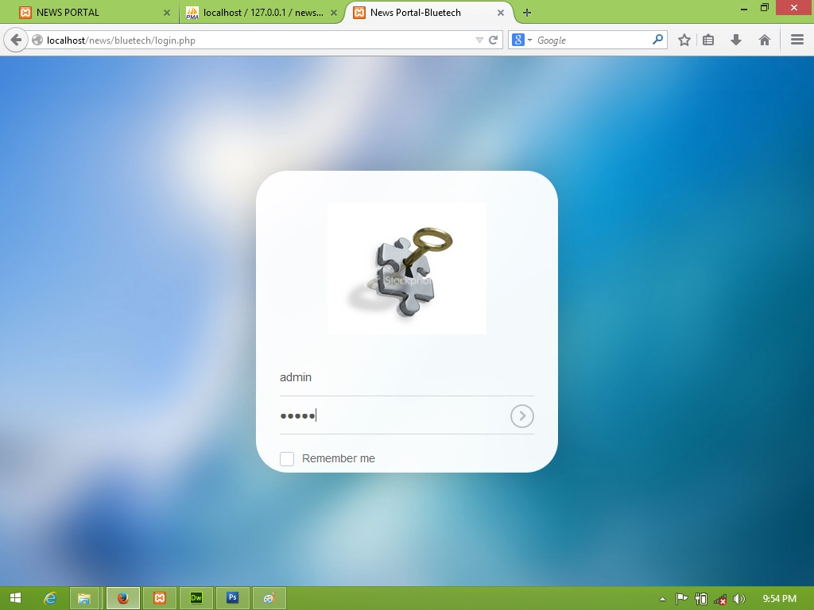

* This is help to administrator can login and open admin panel.
* If user name and password is not match then it will not open admin panel.

**[2] Admin Home: ~**

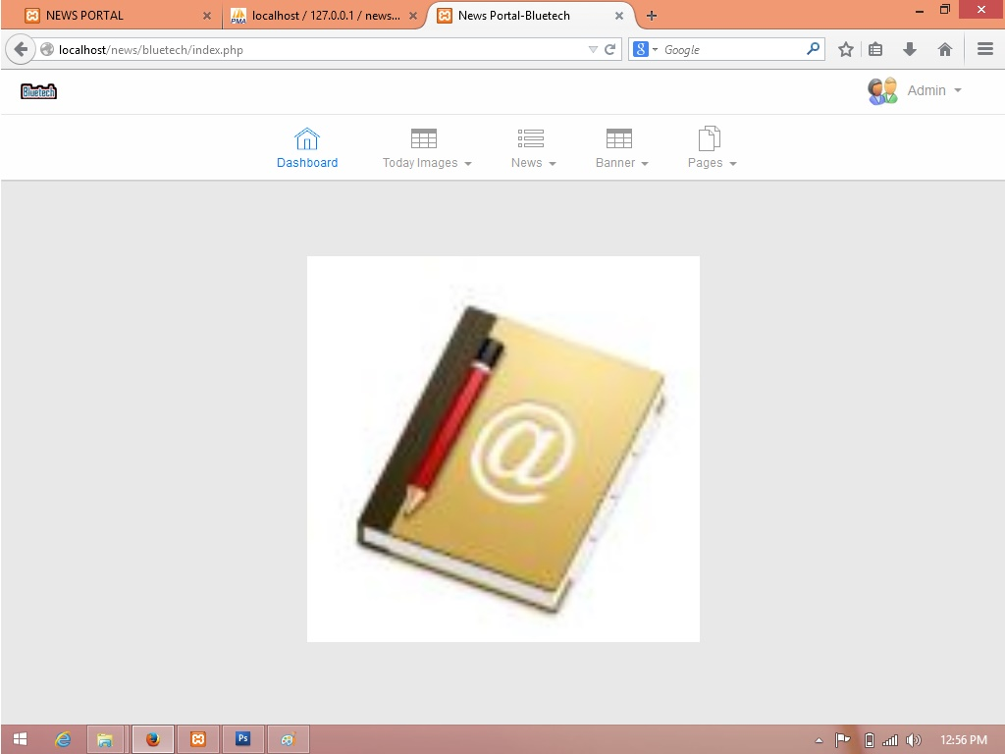

* This is administrator home page in admin panel.
* Admin can see all the different different funcationality for different different purpose.
* Admin want to add any new news then go news tab and click on it and add it and it can also edit and view also.it is same like other funcations.

**[3] Add Image: ~**

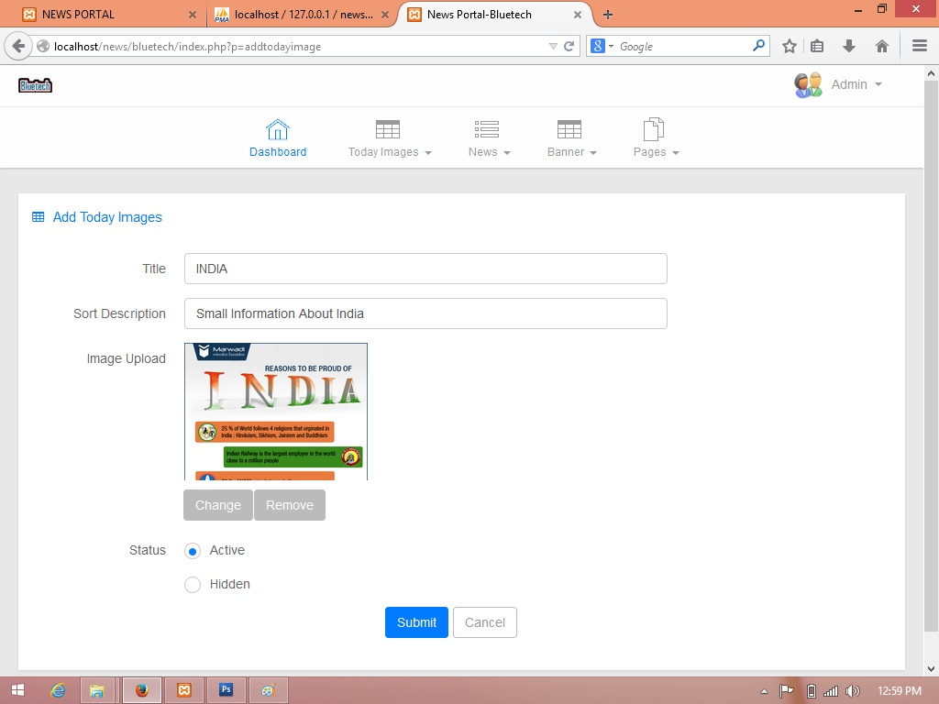

* This page is use to upload a new image in gallery.
* When admin add new image in gallery then it will specify image title, sort descrioption, image and its status.
* If Status is active then it will display in client side otherwise it will display at when user click view all option in client side.

**[4] View & Edit Image: ~**

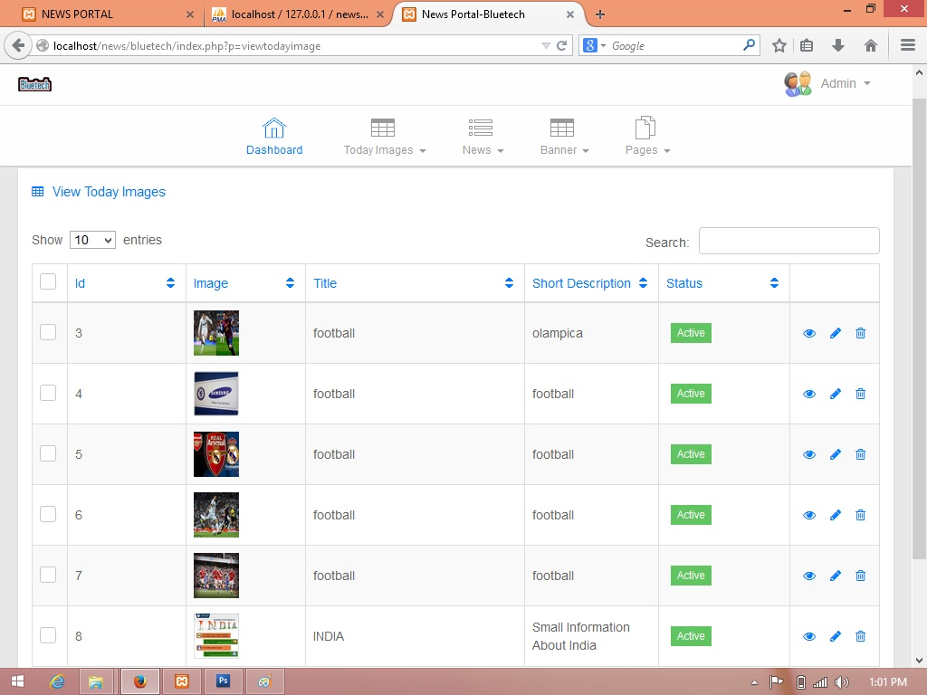

* This page is view the uploaded gallery image.
* If admin wants to update or delete the image then it will do here with the help of right side available option.

**[5] Update Uploaded Image: ~**

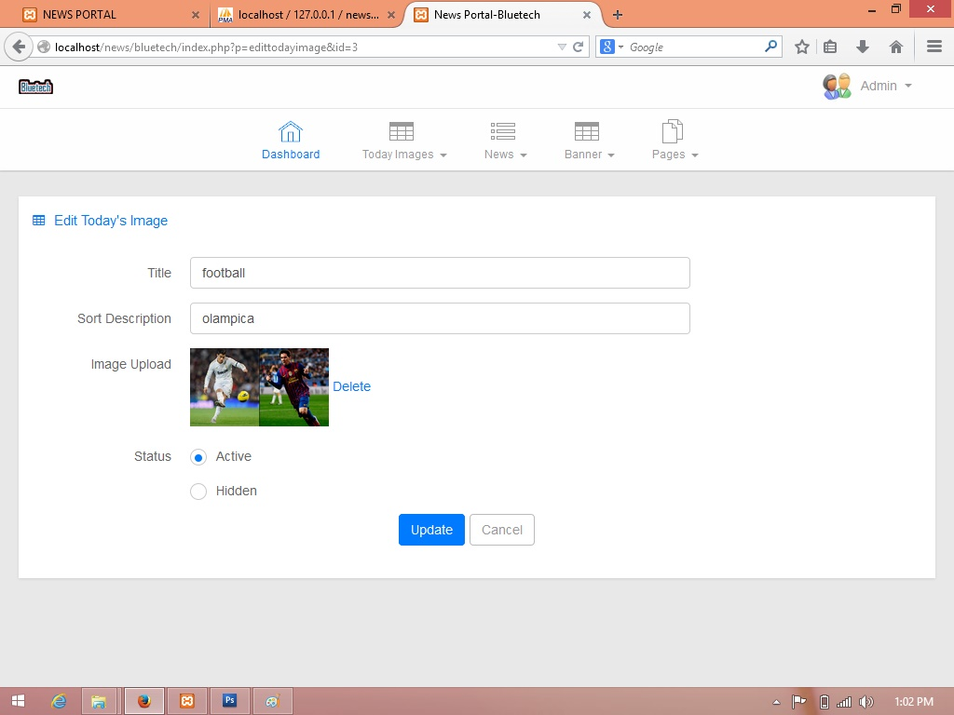

* This page is use to update the gallery image if admin want it.
* It will display past uploaded image as well as it title and description.
* If admin want to change title, sort description and image then it can be by here.

**[6] Add News: ~**

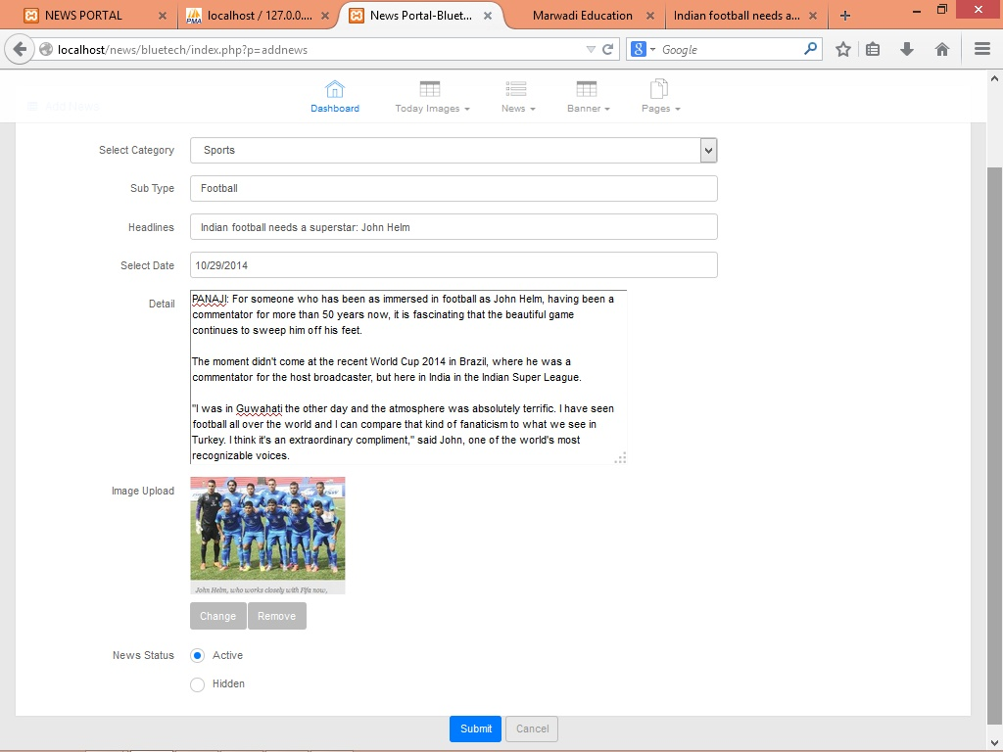

* This page is use to admin can upload new news.
* It will also upload news related image also.
* Admin can also specify the status of the news or other more field.

**[7] View & Edit News: ~**

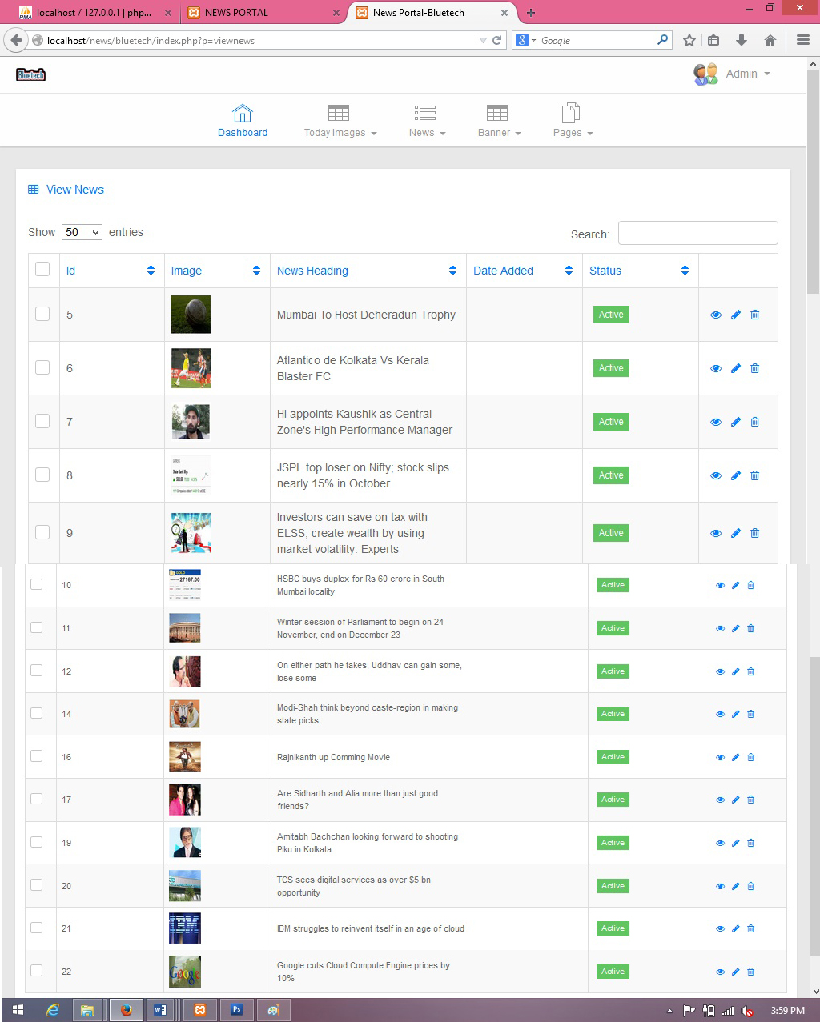

* This page is use to display uploaded all news.
* If user want to update or delete any news then it will do with the help of right side option.

**[8] Update News: ~**

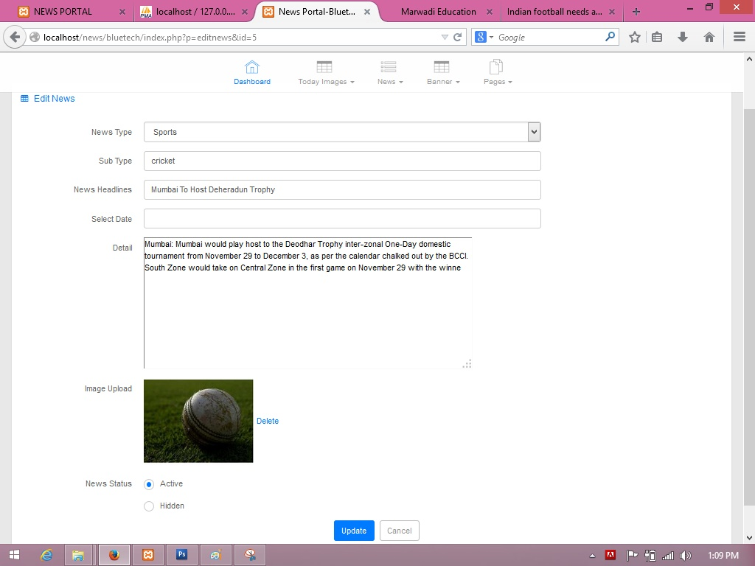

* This page is use to admin can update the uploaded news.
* It also change any detail about news or add news content in the news then it is possible here.

**[9] Add New Banner: ~**

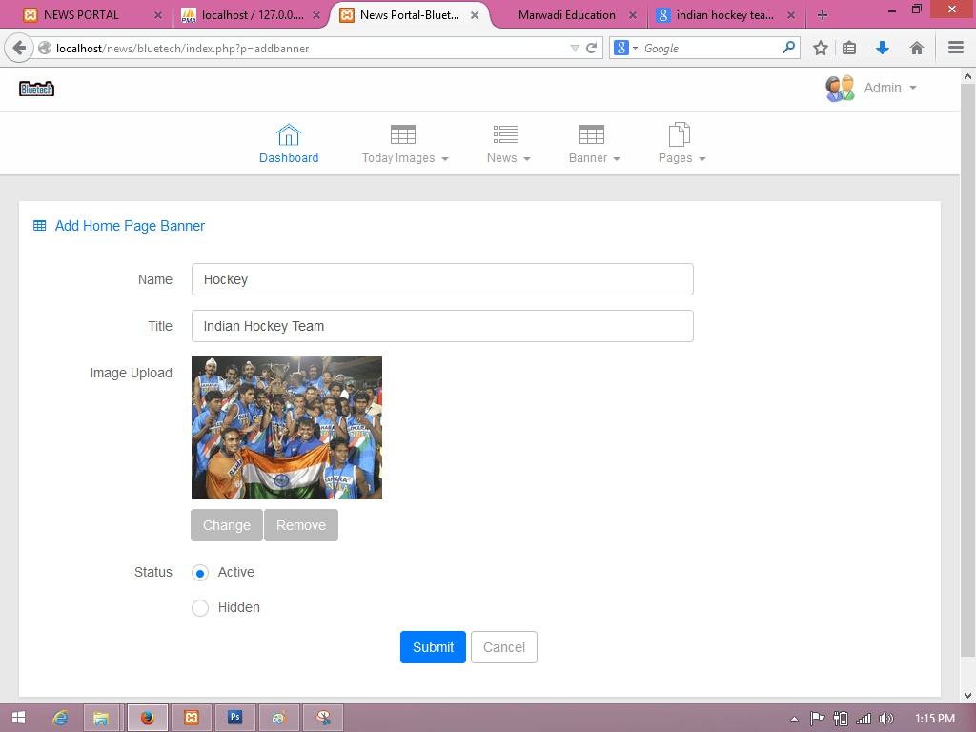

* This page is use to add new banner.
* When admin upload any new banner then its require to specify banner name, banner title, banner image and status.
* If status is active then it will display otherwise it will not display.

**[10] Update Banner: ~**

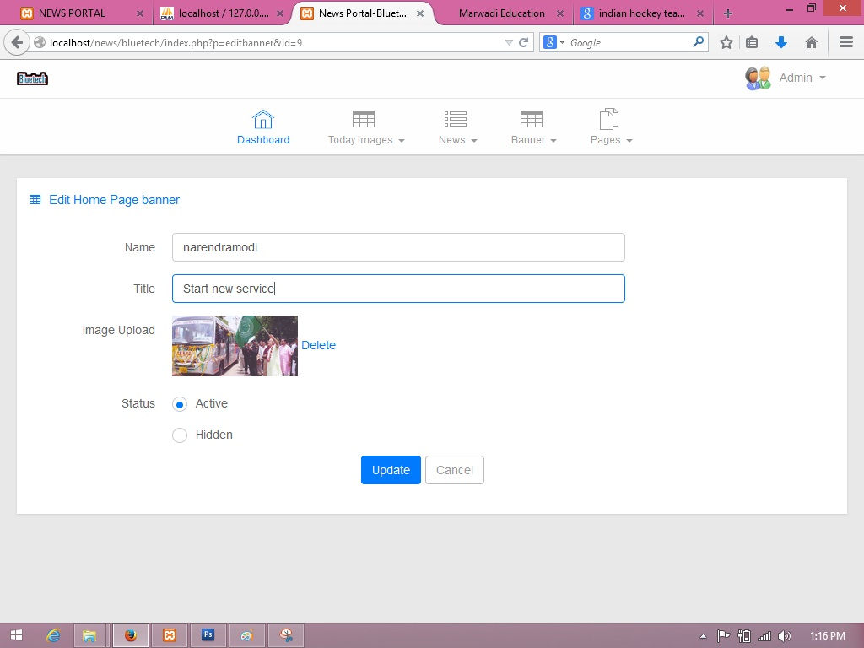

* This page is use to update the uploaded banner.
* When admin want to update banner then it will done by here.

**[11] Add New Page: ~**

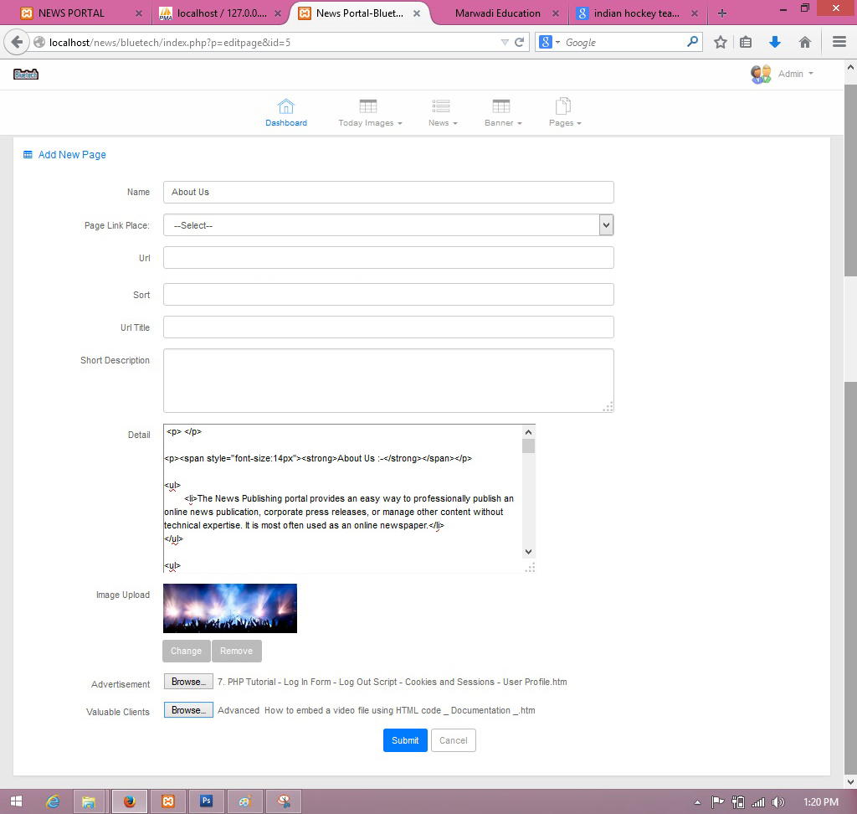

* This page is use to add a new page dynamically in client side.
* When admin add a new page dynamically then specify page name in name field and select page link and more important is write html code in detail field which you want to add news page.

**[12] Change Account setting: ~**

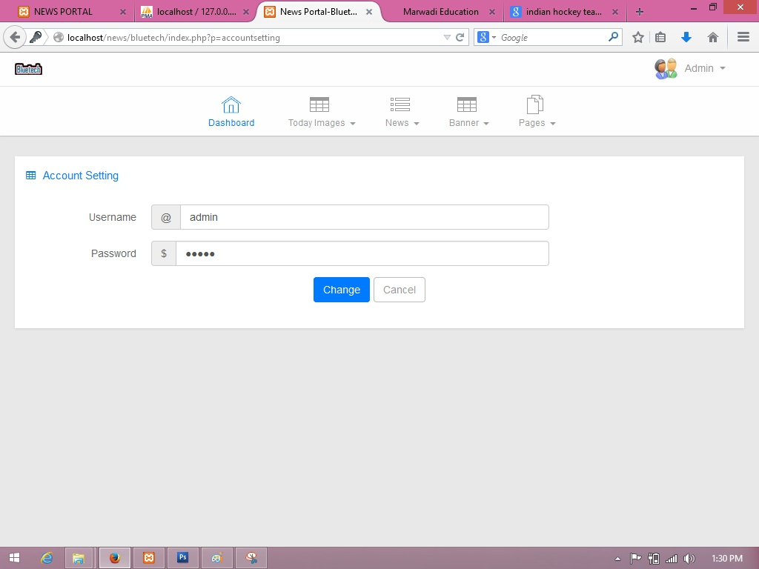

* This page is use to change the admin username and password.
* **Client Side: ~**

**[1] Home: ~**

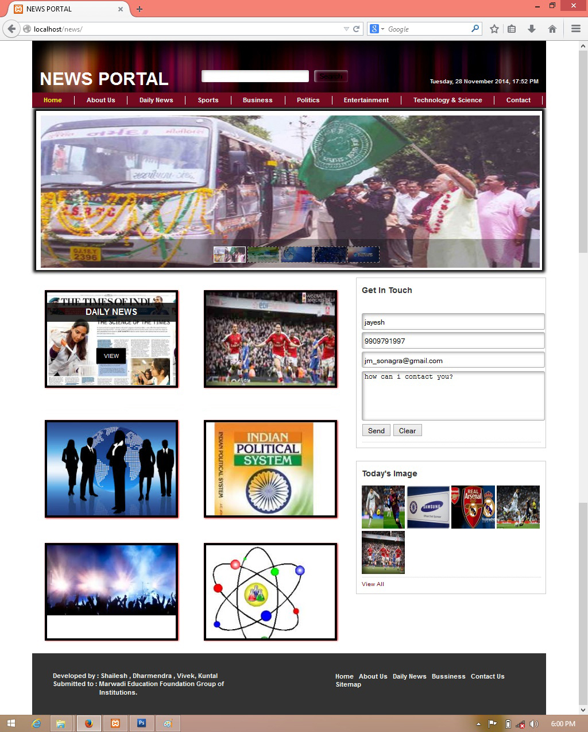

* This page is home page and all other link available here.
* User can jump all other page from here.

**[2] About Us: ~**

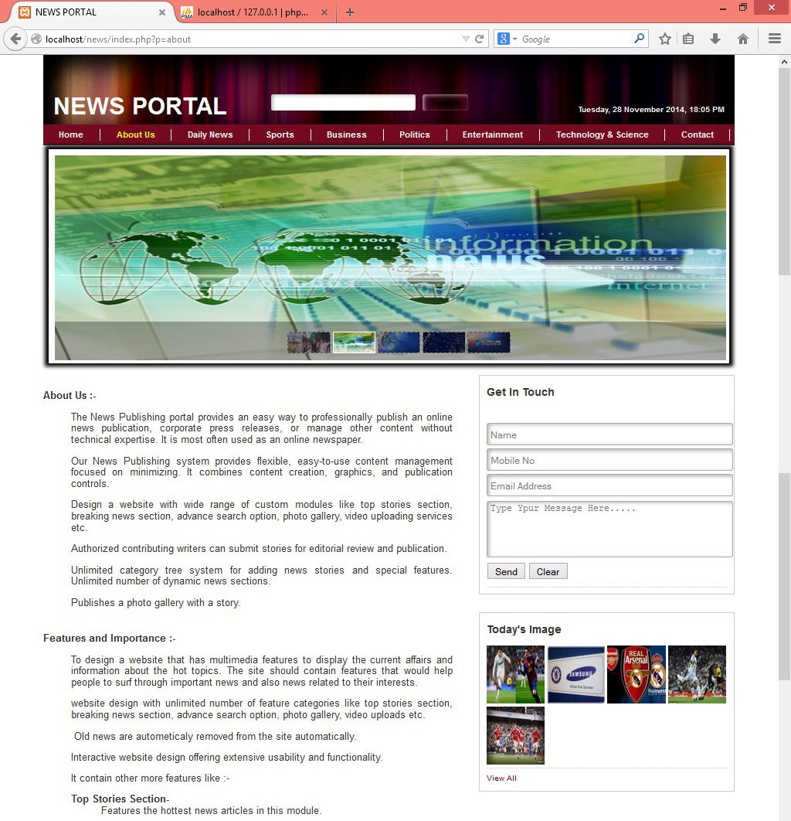

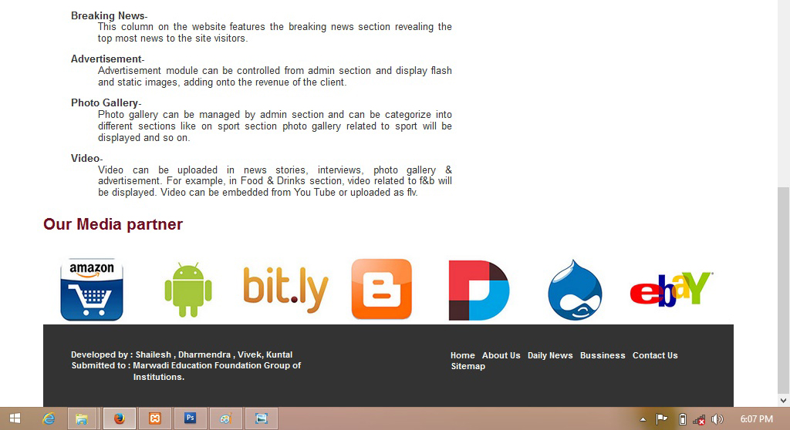

* This page is display all the description or information about this web site.
* It can also display the web site’s media partner.

**[3] Daily News: ~**

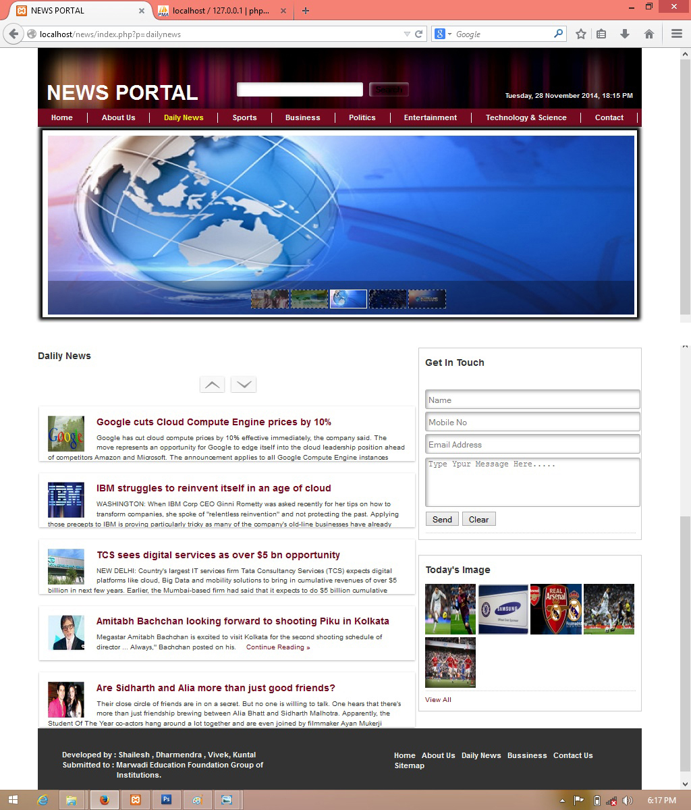

* It will display all general new.
* Other is it will display all type of news in single page
* When user want to show more new then up-down arrow is display when user click on it then it will show more news.

**[4] Sport News: ~**

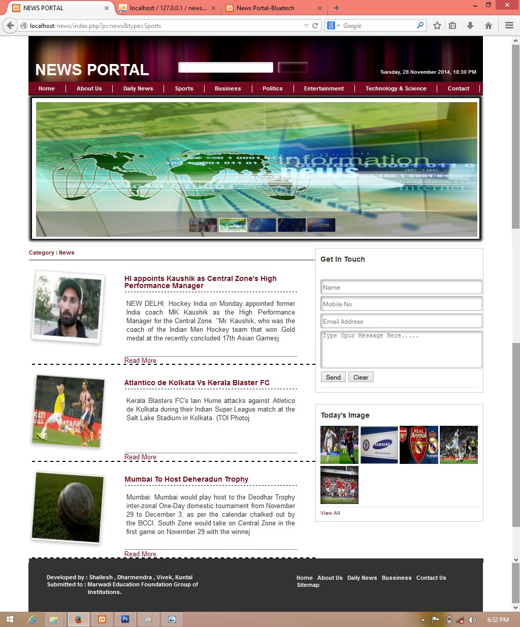

* This page will display sport’s related news.
* It is display more description when user click on read more option.

**[5] Business News: ~**

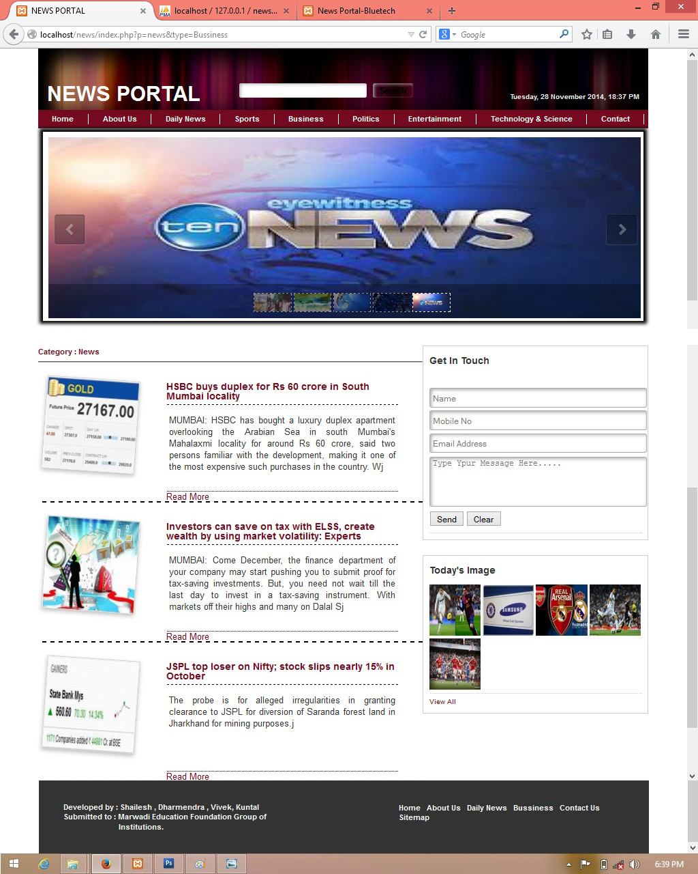

* This page display business related news.
* It is display financial, marketing or other news also can be display with its image so viewer can easily understand it.

**[6] Political News: ~**

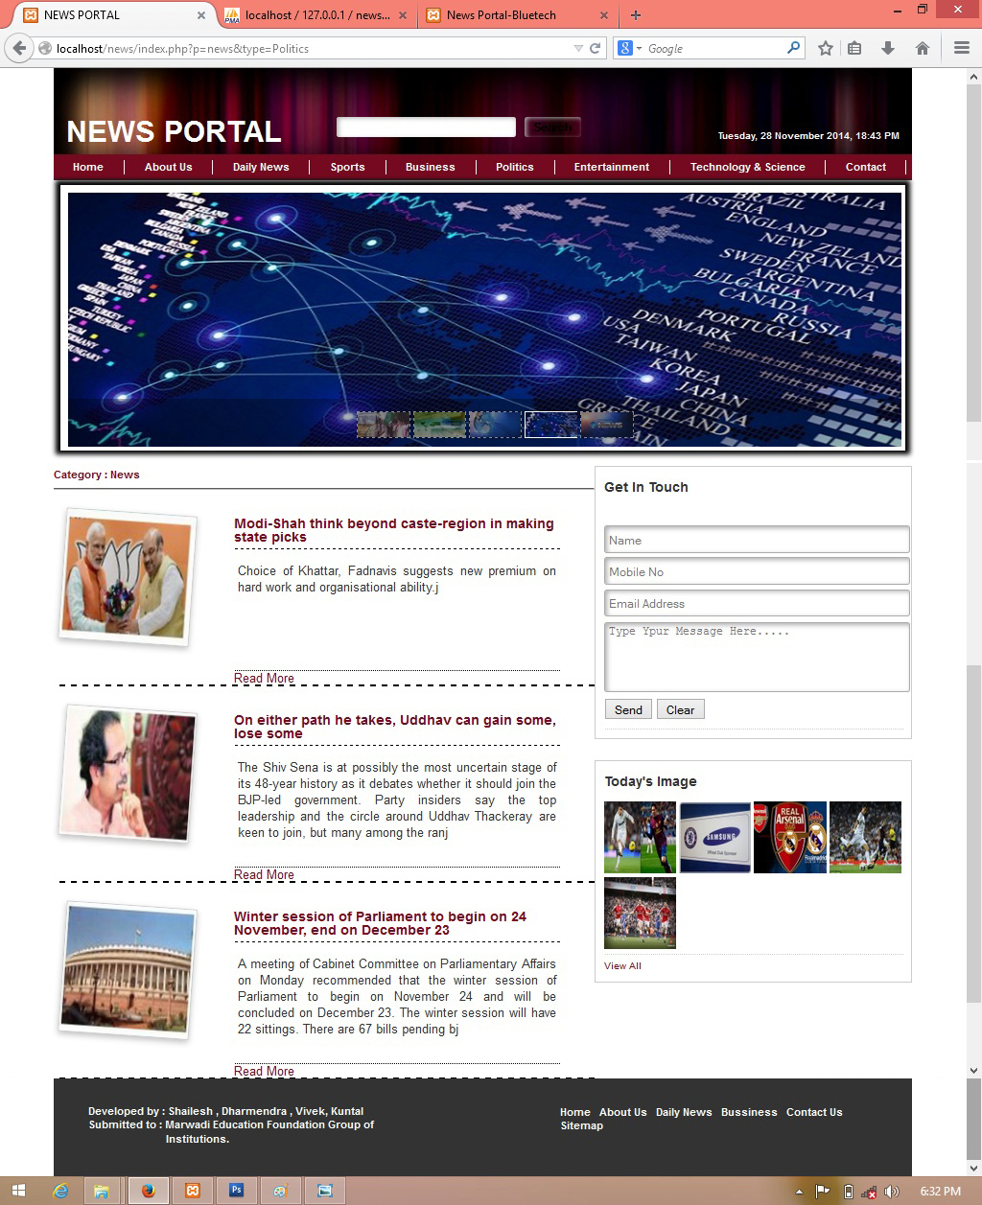

* It is display all political news.
* It is as well as it can display sort decription and its related image so viewer can easily understand.

**[7] Entertainment News: ~**



* It is display all entertainment related news.
* Enetertainment like which new filem comming soon, other filem shows, all actors stories etc.

**[8] Science & Technology News: ~**

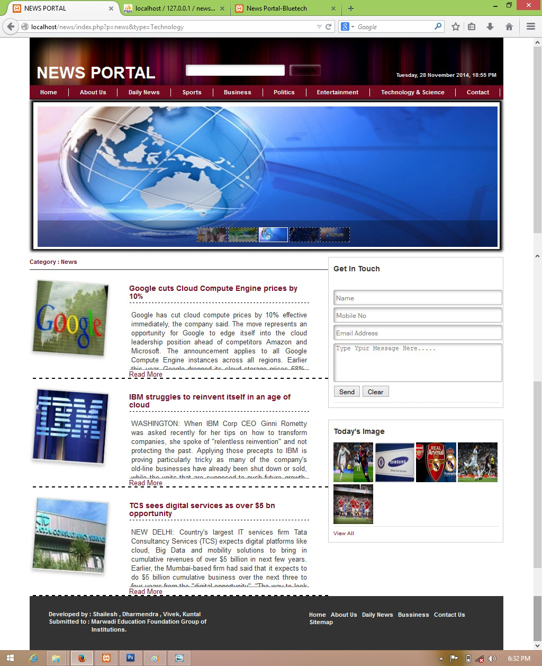

* This page is display all science and new technology related news.
* Means which new technology is come market and new invention etc.

**[9] Read More Detail News: ~**



* This page is display whole description which type of news viewer click.
* It means when user show sort description and he/she want to show more detail then they need to click ‘read more’ option then that news related whole description will be open.

**[10] Gallery: ~**

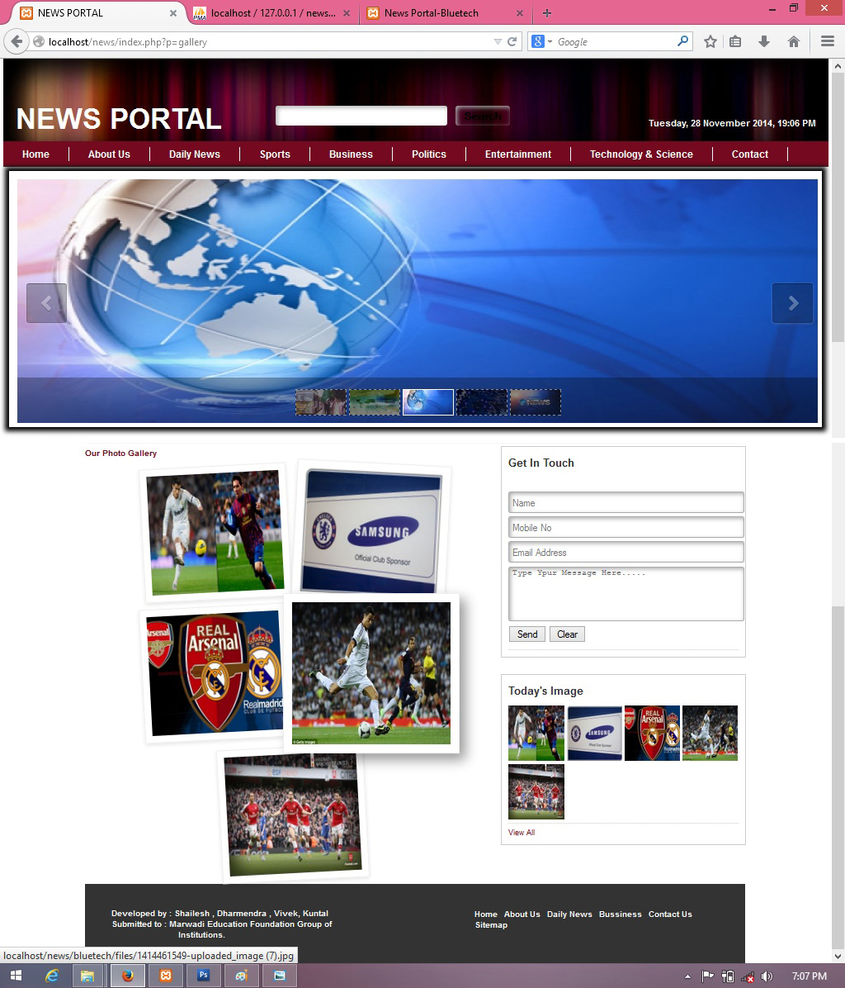

* This page will display all the today images.
* When user click on ‘view all’ option then it will open.

**[11] Contact: ~**



* This page is display contact list.
* When client or viewer have some query then it can send message also and directly contact to us.

**CONCLUSION**

Finally a NewsPortal.com is designed and developed just for end user and their connections with their friends. We provide different facilities from which user can get their mind fresh from their busy life and gets opportunity to read online news with their friends, watch and post important information.

**Bibliography**

* **BOOKS**
  1. The php4.
  2. The complete reference web design.
  3. The complete reference HTML.
  4. The www using HTML
  5. Learn php & HTML
* **WEB SITES**

1. [www.timesofindia.com](http://www.timesofindia.com)
2. [www.sandesh.com](http://www.sandesh.com)
3. www.indiatoday.com